Ijarah Restructure
UT Document

Document History
Author | Version | Date | Description
Taha Faruqi  Muhammad Ali | V1.0 | 8th Apr 2026 | Initial Document
Taha Faruqi | V1.1 | 9th Apr 2026 | Final Document

Table of Contents
Summary 5
Old Arrangement Details 6
Old Arrangement Early Payoff Amount 6
Early Payoff Simulation of Old Arrangement 7
New Restructured Arrangement Creation 9
New Application Details 9
New Application Creation 9
Application Submission 9
Application Status After Submission 10
Offer Acceptance 10
Request Overview Details on Assist 11
Transact Simulation 12
Financial Details 12
Financial Details of Application Part 1 12
Financial Details of application Part 2 13
Servicing Module Section 13
SMB DEAL DETAIL 14
STP Status Enquiry – Bill Generation 15
Bill Generation 15
Generated Bill 16
Rosom 16
Bill Status - Received 17
STP status enquiry - Bill Payment Confirmation 17
Credit Admin Stage 17
PO and Vendor Details of Application 19
Financial Information of Application 19
Purchase Order 20
PO Generation 20
Successful Correspondence 20
Updated PO & Contract Status 21
Contract Acceptance 21
Asset Capture Amend 23
Authorization of Asset Capture Amend 24
STP Status Enquiry – Complete 25
STP Accounting Entries 25
Restructured Arrangement Creation 26
Authorization of Restructured Arrangement 30
Arrangement 360 View 30
List of Transaction Entries 31
Multi-supplier Account 31
Fund Transfer 32
FT Creation 32
FT Authorization 33
FT Credited in Previous Loan Repayment Account 33
Payoff 34
Previous Loan Payoff 34
Payoff Authorization 35
Arrangement after Payoff 36
Schedule 36
Transaction Entry After Payoff 36

Summary
The Ijarah Restructuring UT document evidences the successful closure of the existing arrangement through full payoff and the creation of a new restructured facility, featuring an extended tenor and a financing amount equal to the early settlement payoff amount of the previous loan.

Old Arrangement Details
Old App ID: B3BV2QC
Contract Amount: 14,250
Tenor: 24 Months

Old Arrangement Early Payoff Amount
Request
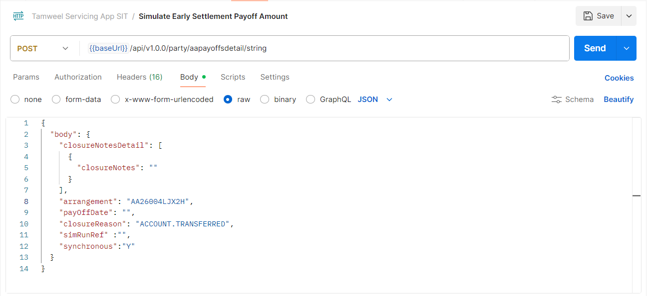
Response
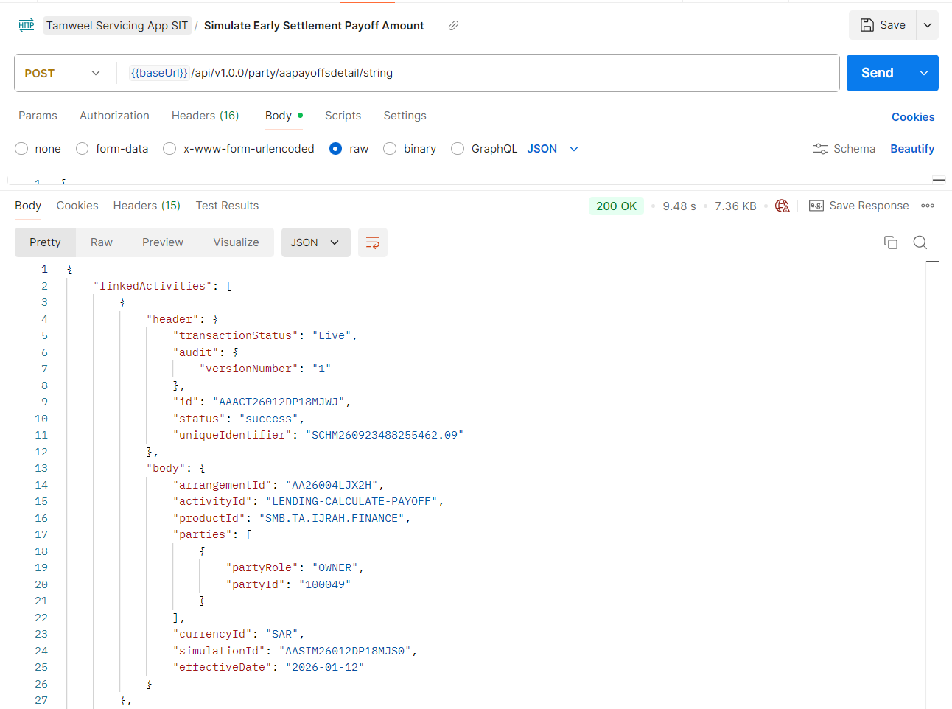

Early Payoff Simulation of Old Arrangement
Request
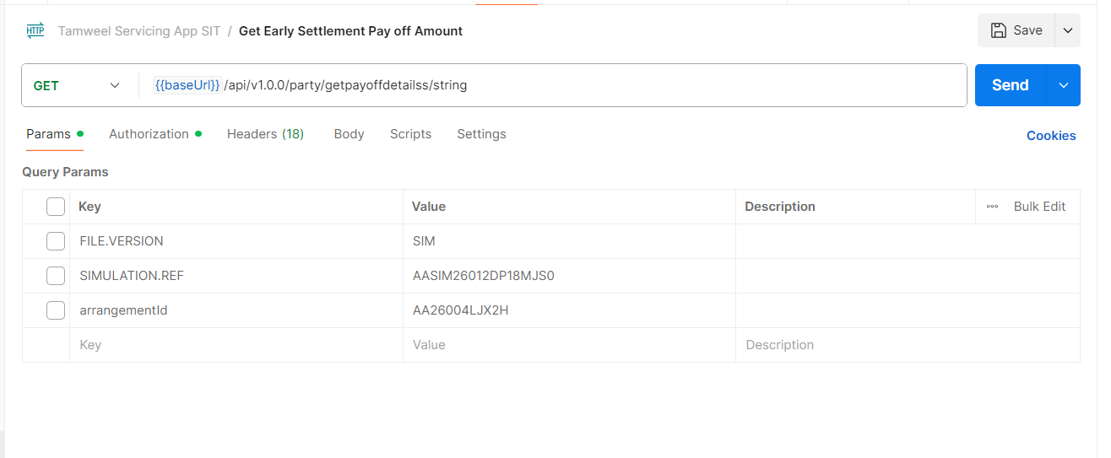
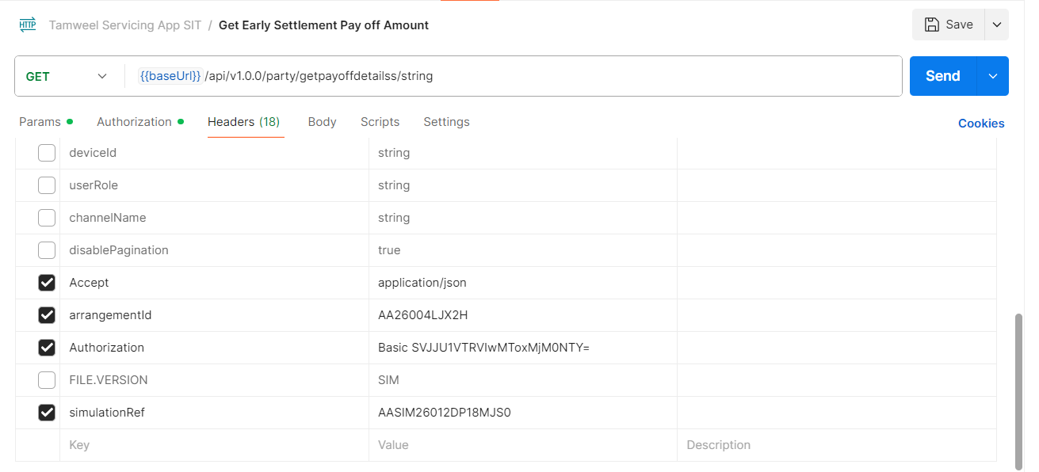

Response
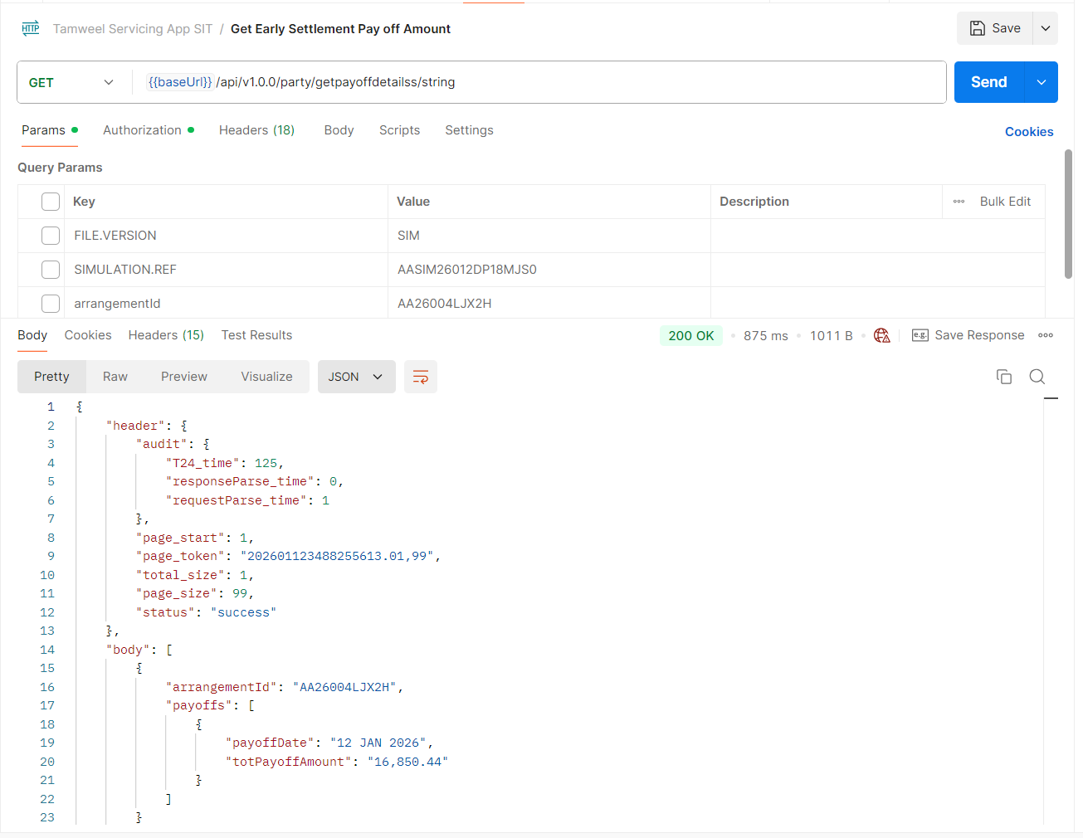

New Restructured Arrangement Creation

New Application Details
Application ID: 54LKFLD
Contract amount: 16,850.44
Contract Tenor: 36 Months

New Application Creation
Application creation through CreateApplication API.
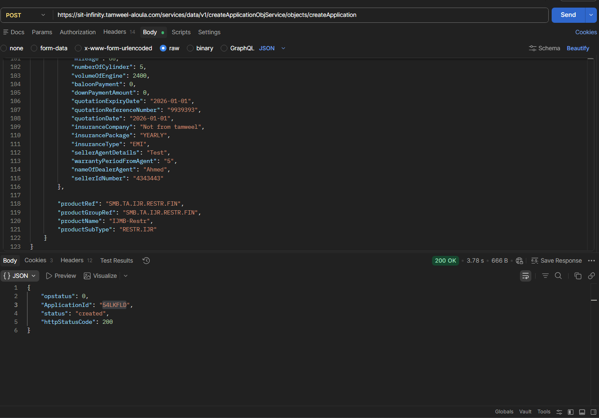

Application Submission
Application submission through SubmitAPI.
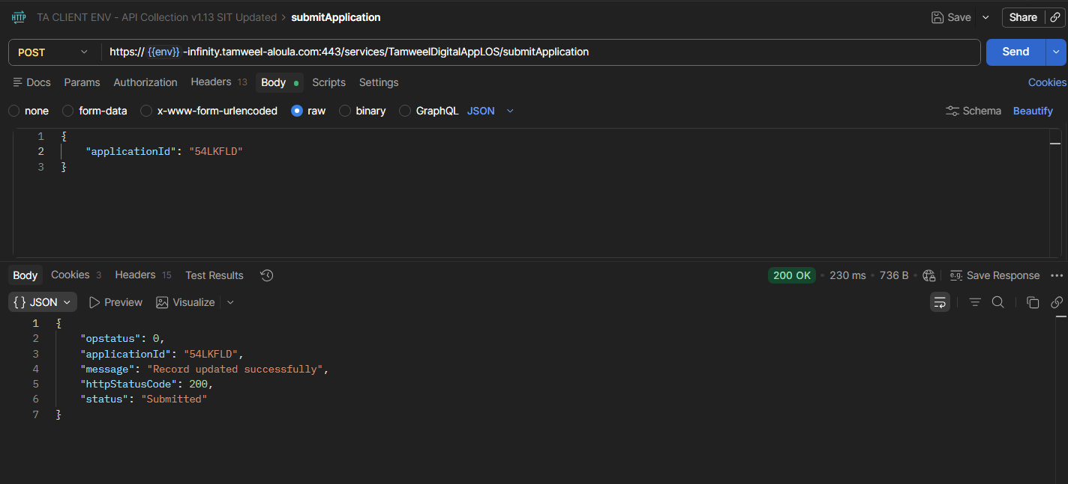

Application Status After Submission
Submitted stage is marked as completed. As response received from Qarar is Accepted and Applied loan amount is less than 75,000, STP flow is initiated because of which offer is generated.
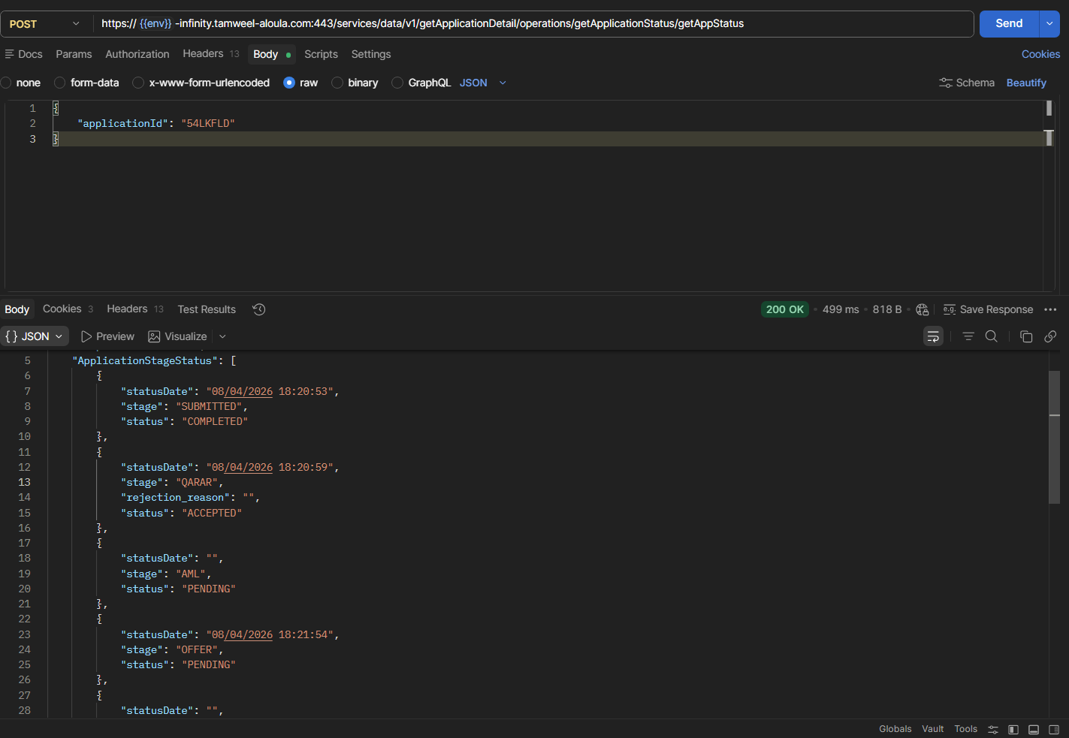

Offer Acceptance
Offer is accepted through UpdateStageStatus API.
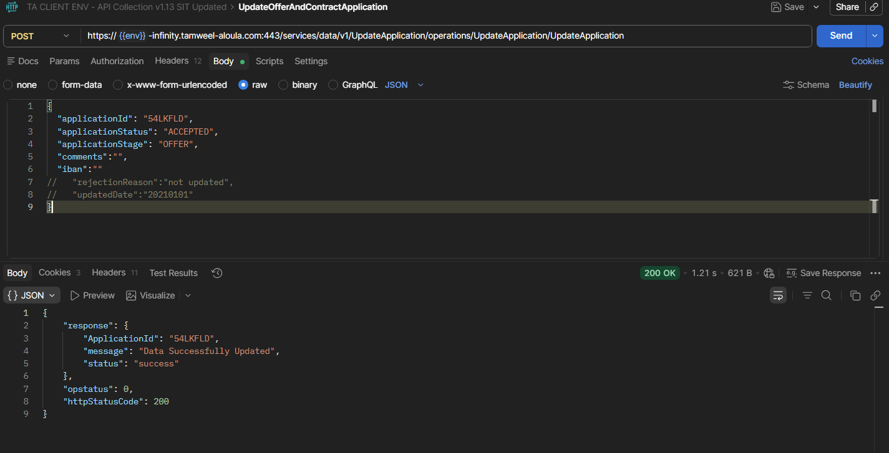

Request Overview Details on Assist
Request Overview details in which Simulation ID alongside with Scheme is reflected.
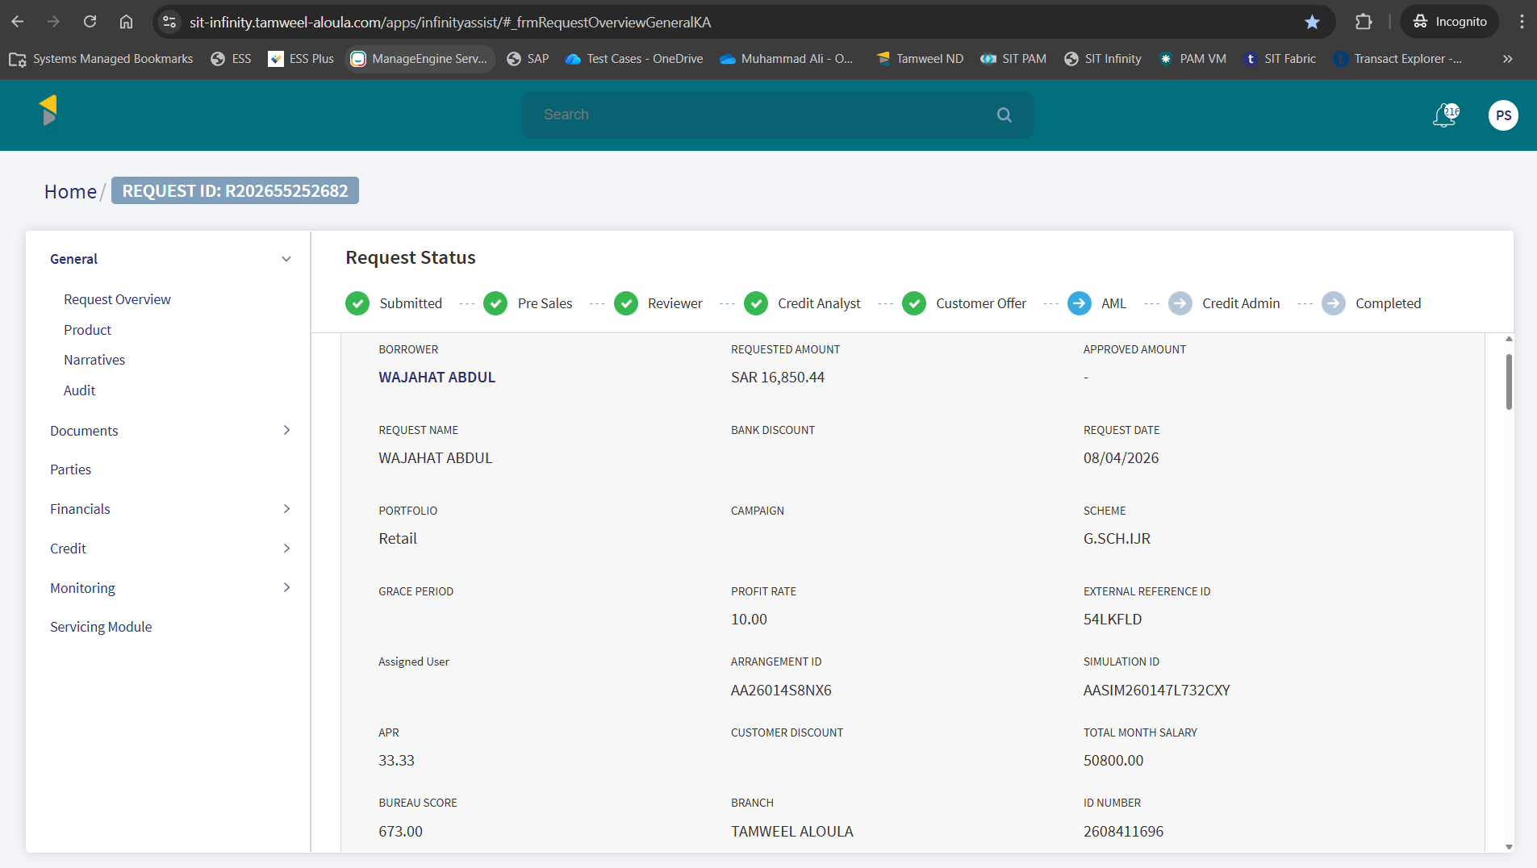

Transact Simulation
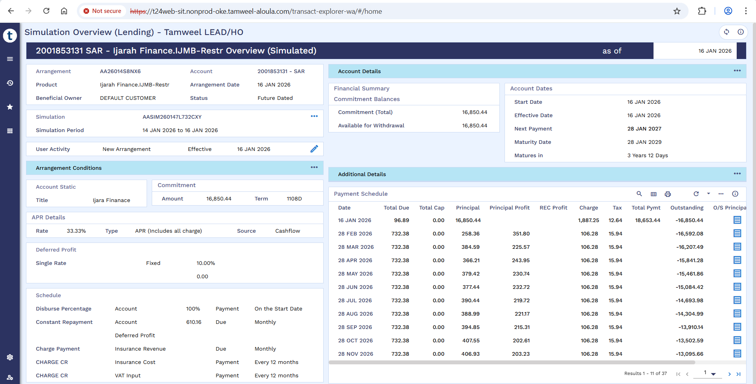

Financial Details

Financial Details of Application Part 1
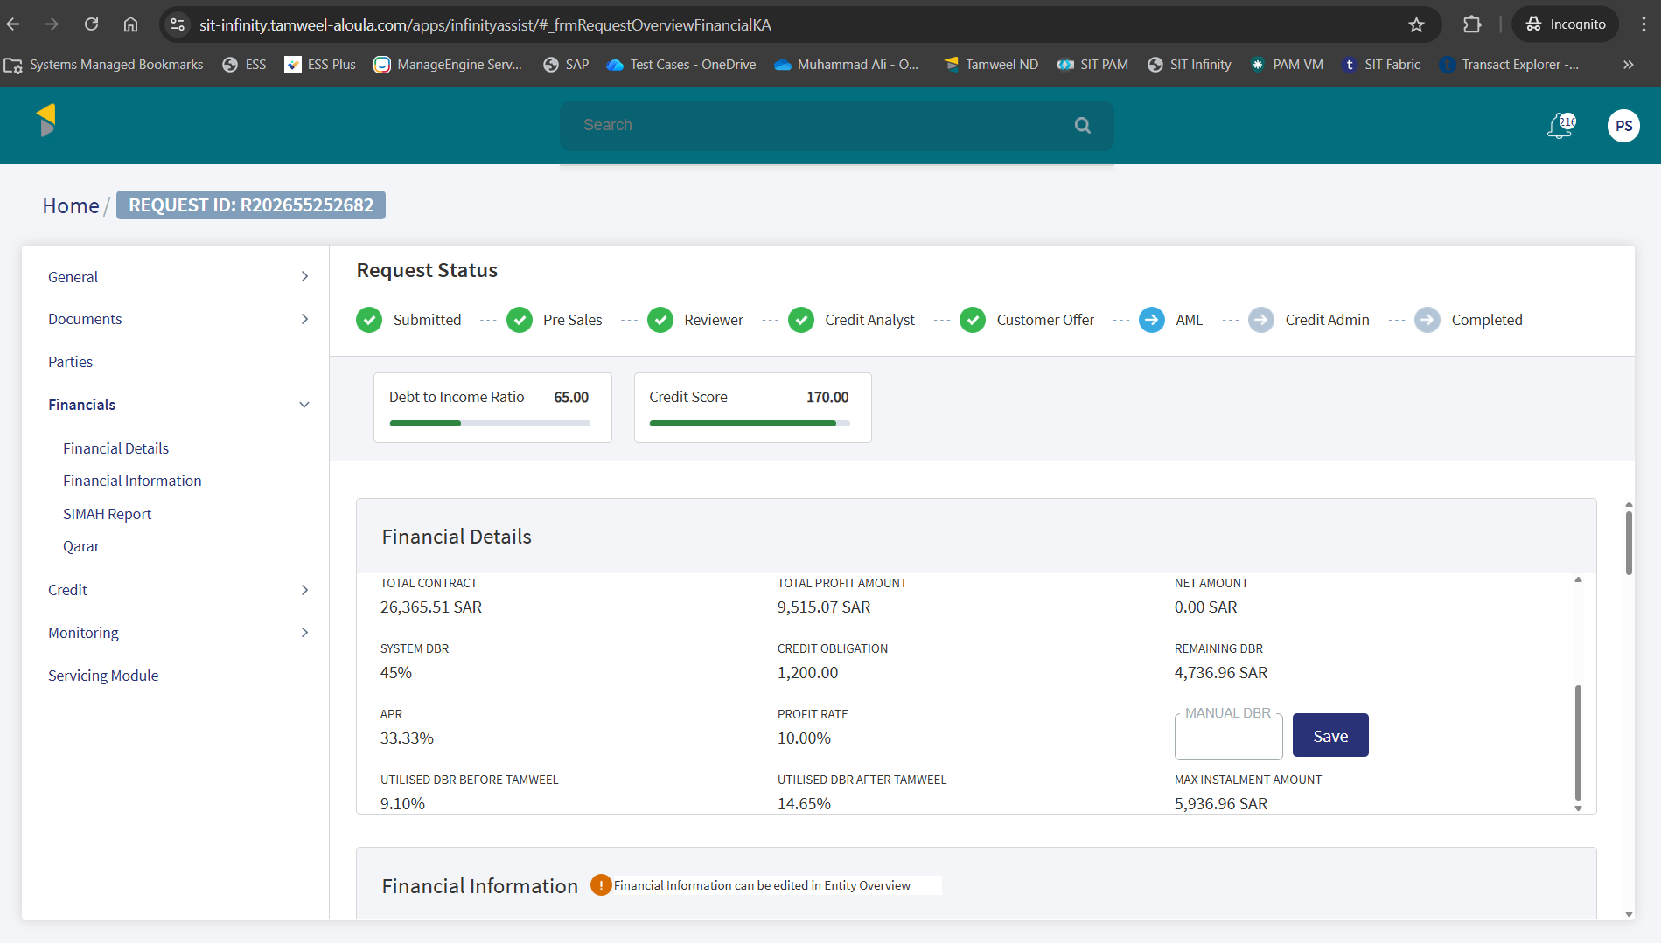

Financial Details of application Part 2
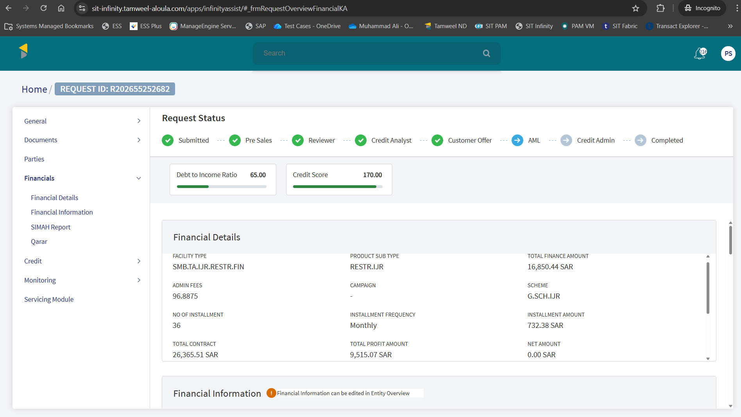

Servicing Module Section
Servicing module section reflecting existing application details.
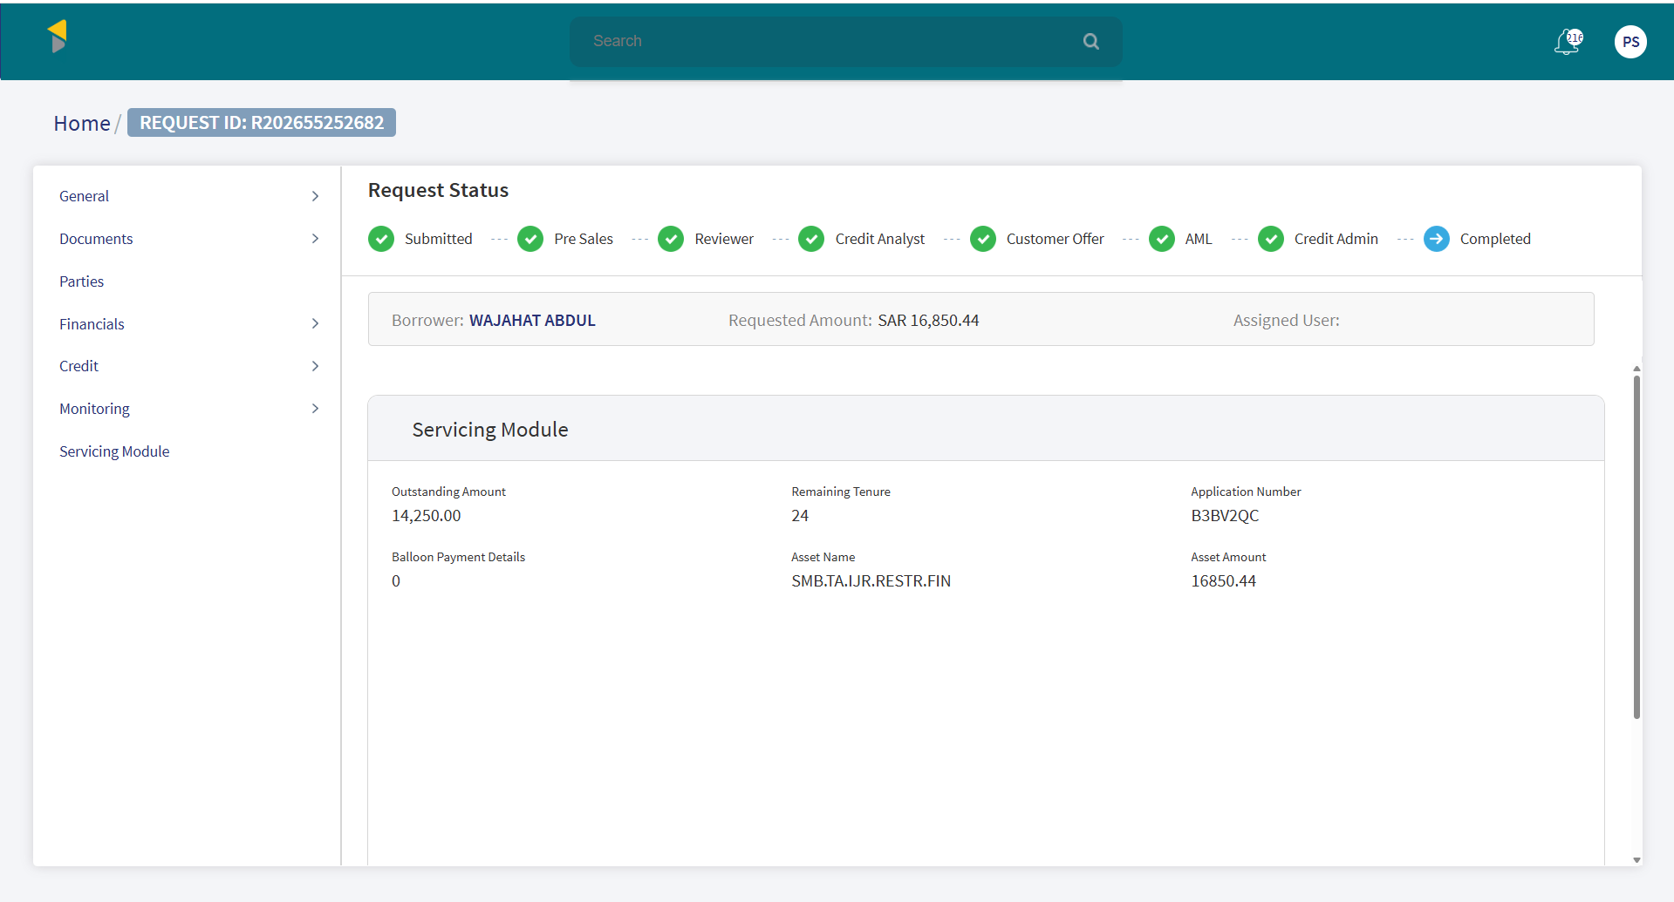

SMB DEAL DETAIL
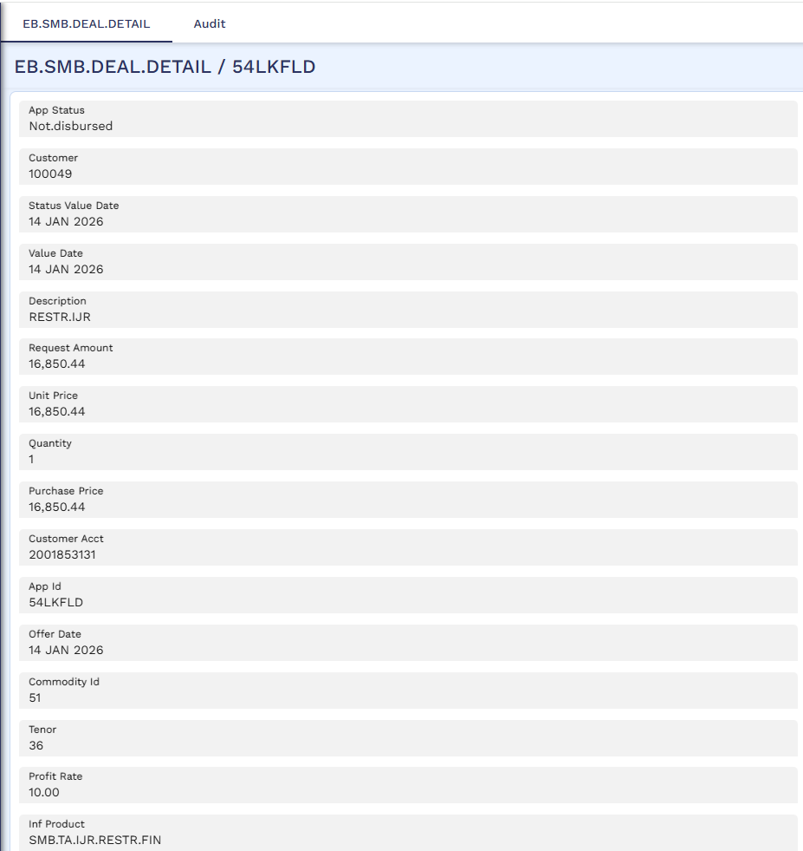
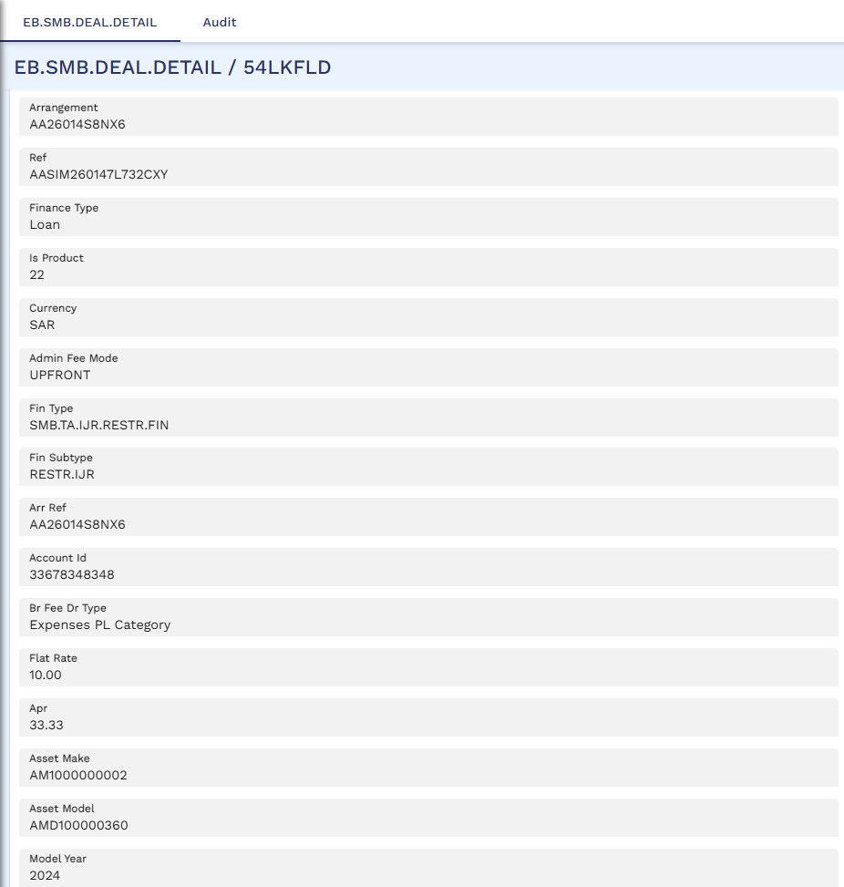
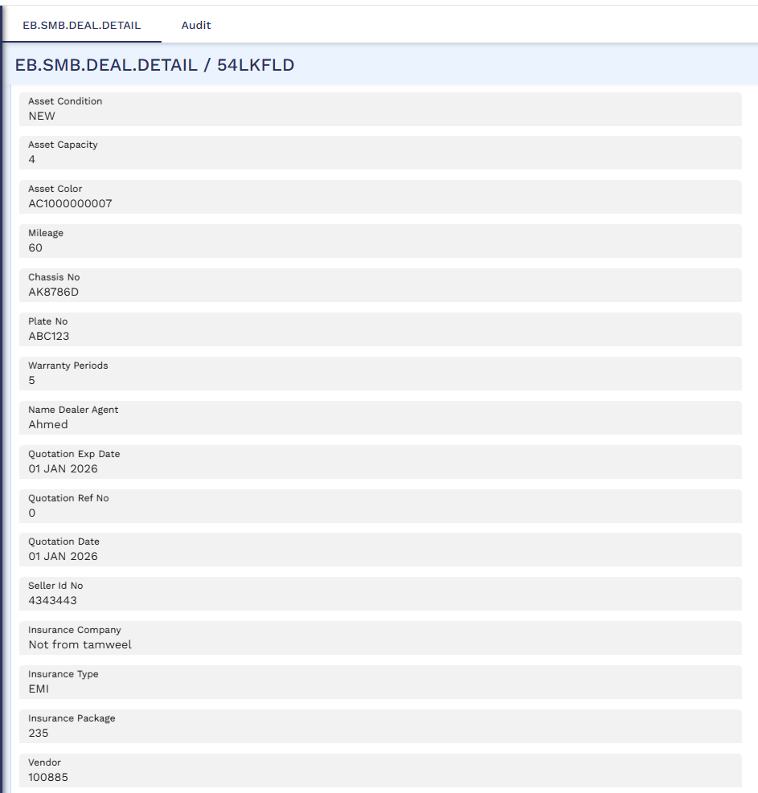
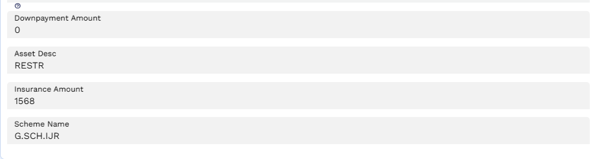

STP Status Enquiry – Bill Generation
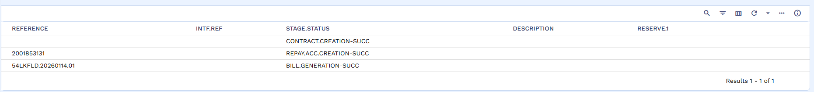

Bill Generation
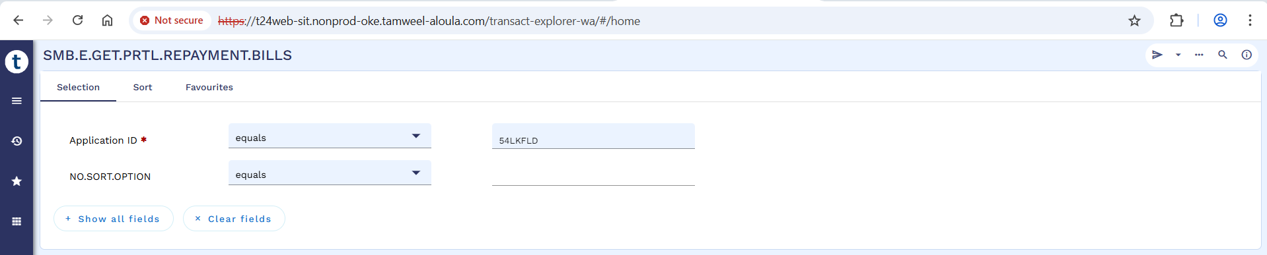

Generated Bill
Below screenshot shows status as uploaded.
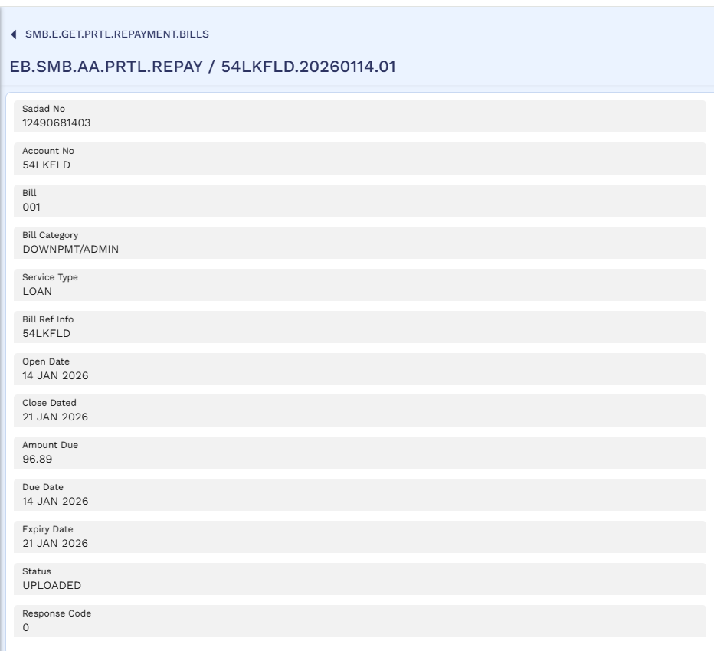

Rosom
Admin bill is paid through rosom.
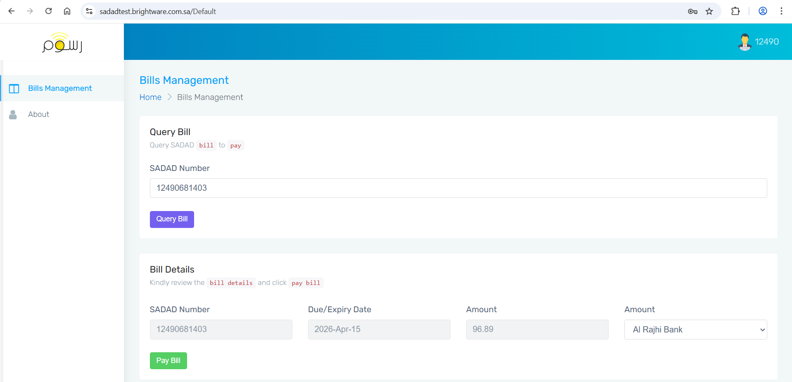
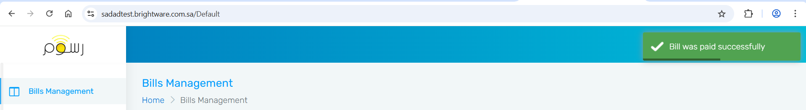

Bill Status - Received
After bill is paid, the status changes to Received.
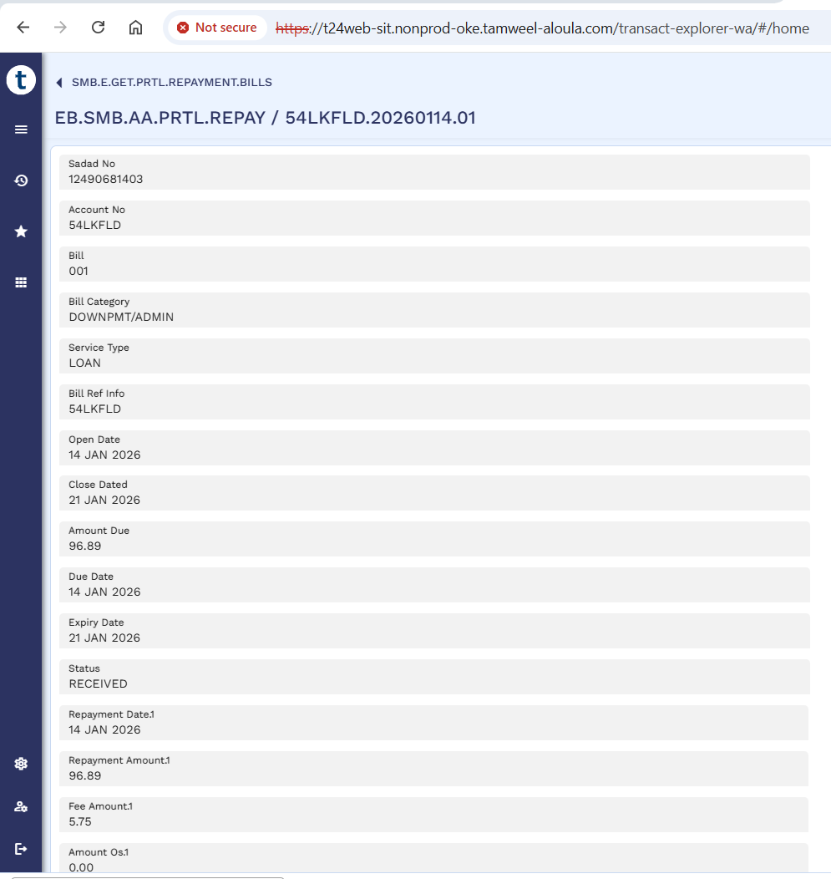

STP status enquiry - Bill Payment Confirmation
Below screenshot shows bill payment confirmation as successful.
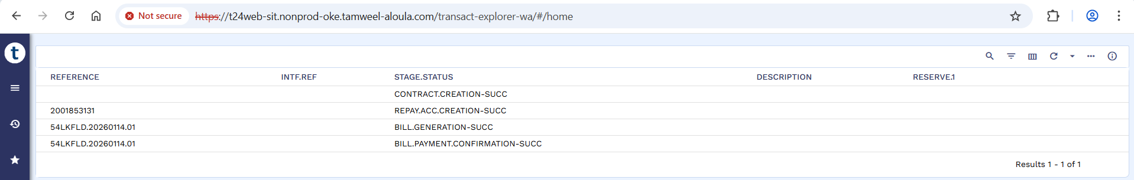

Credit Admin Stage
Admin Fees is marked as Paid and application is visible in Credit Admin’s queue to claim.
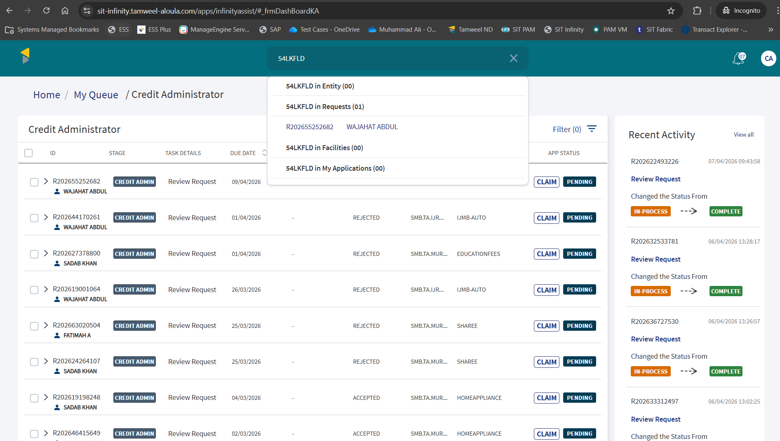

Application is claimed by Credit Admin and is visible in Credit Admin’s My Tasks Tab.
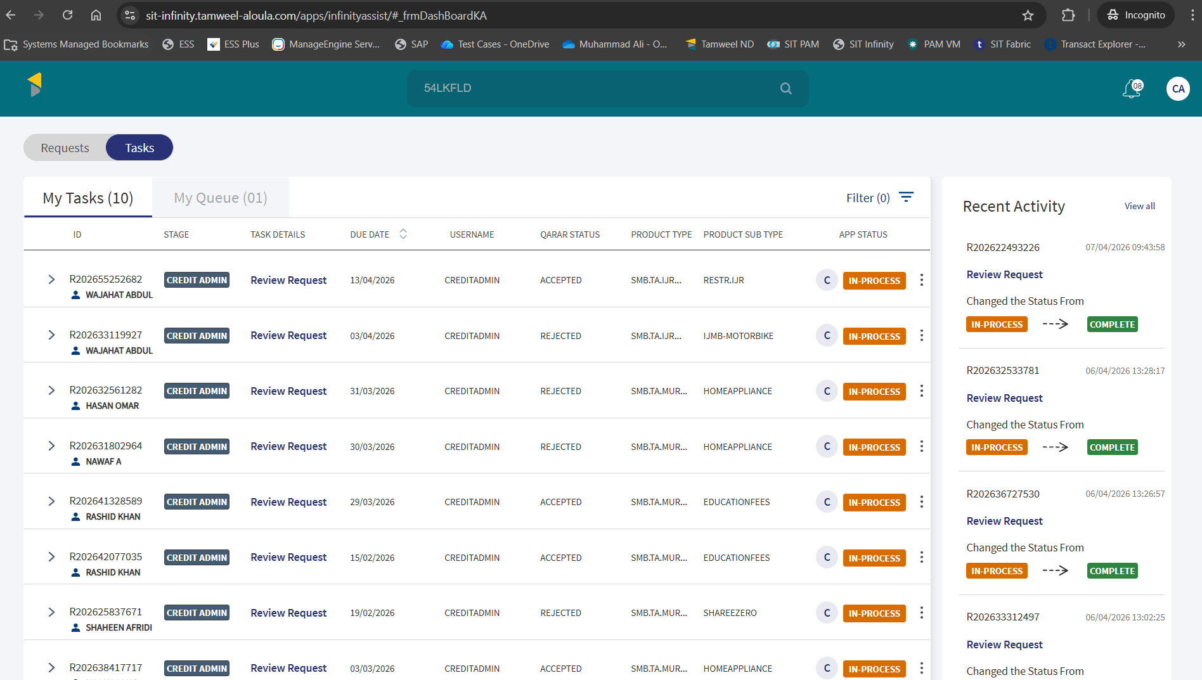

PO and Vendor Details of Application
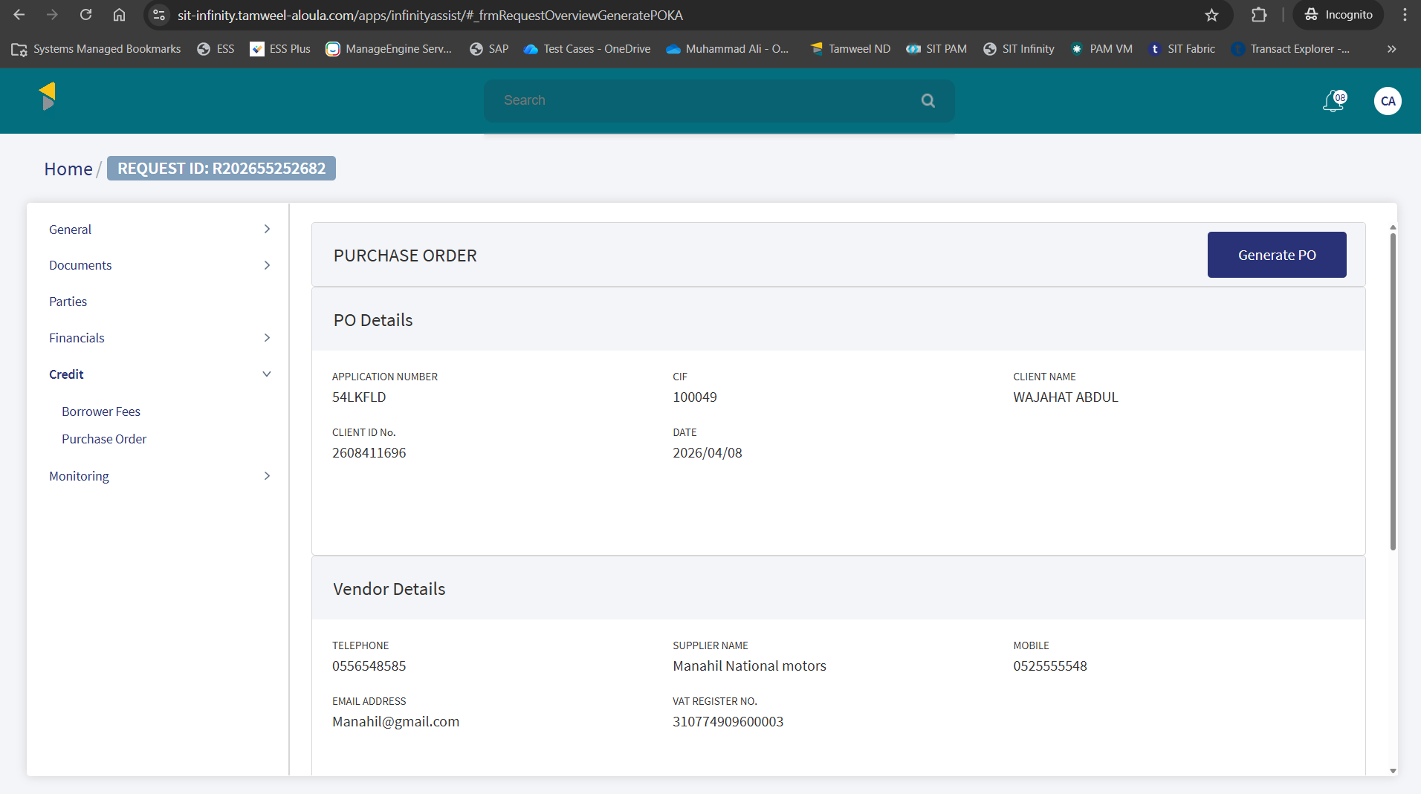

Financial Information of Application
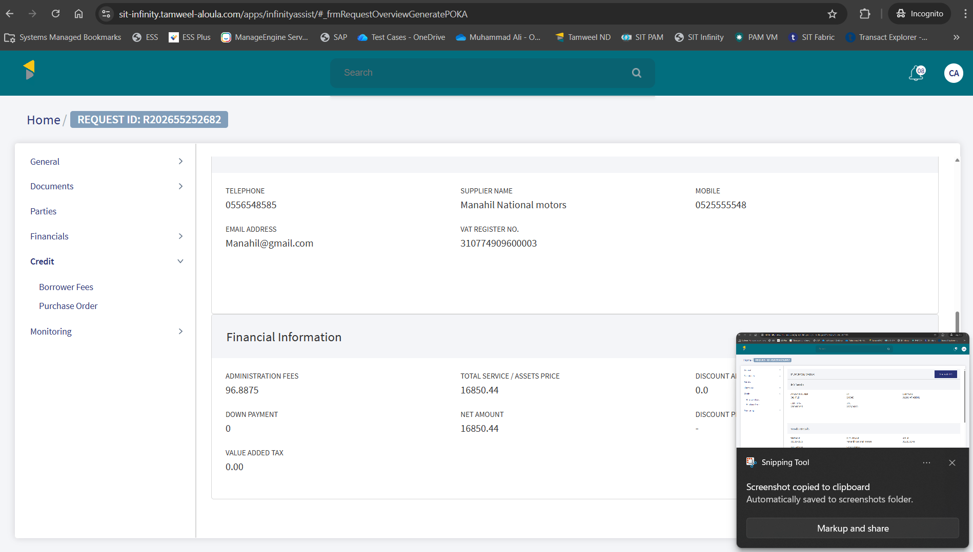

Purchase Order

PO Generation
Below screenshot shows that PO is generated.
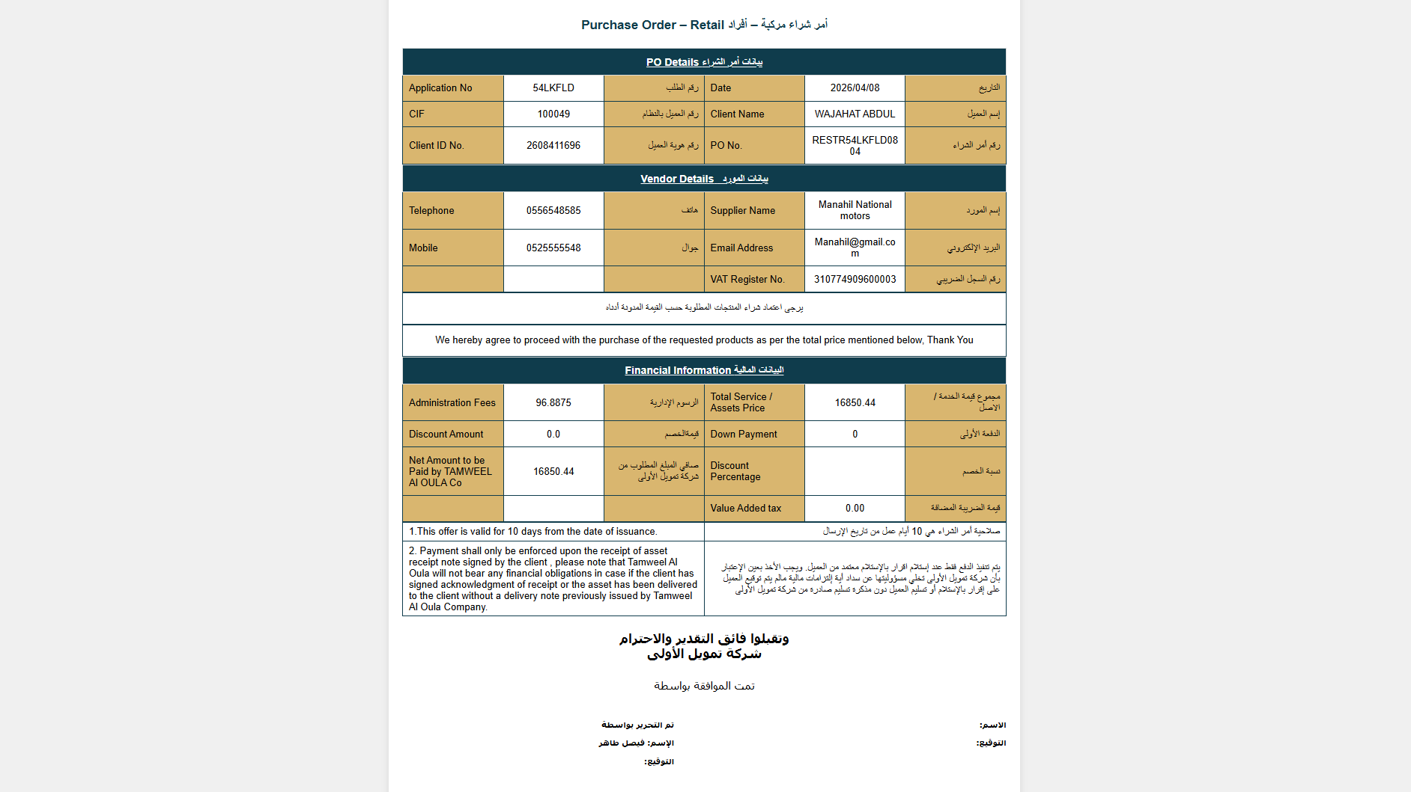

Successful Correspondence
Email is sent successfully for PO.
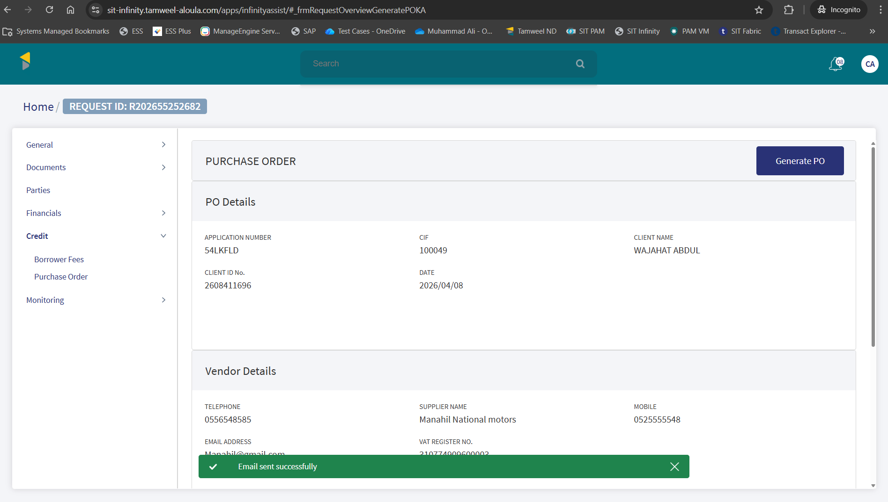

Updated PO & Contract Status
PO stage is updated to accepted and contract status is updated to generated.
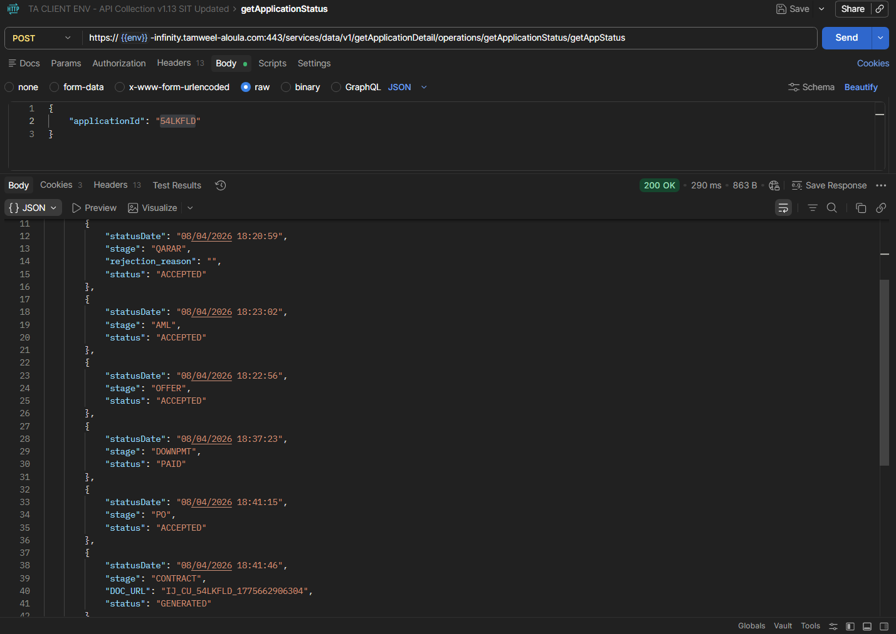

Contract Acceptance
Contract is accepted using UpdateStage Status API.
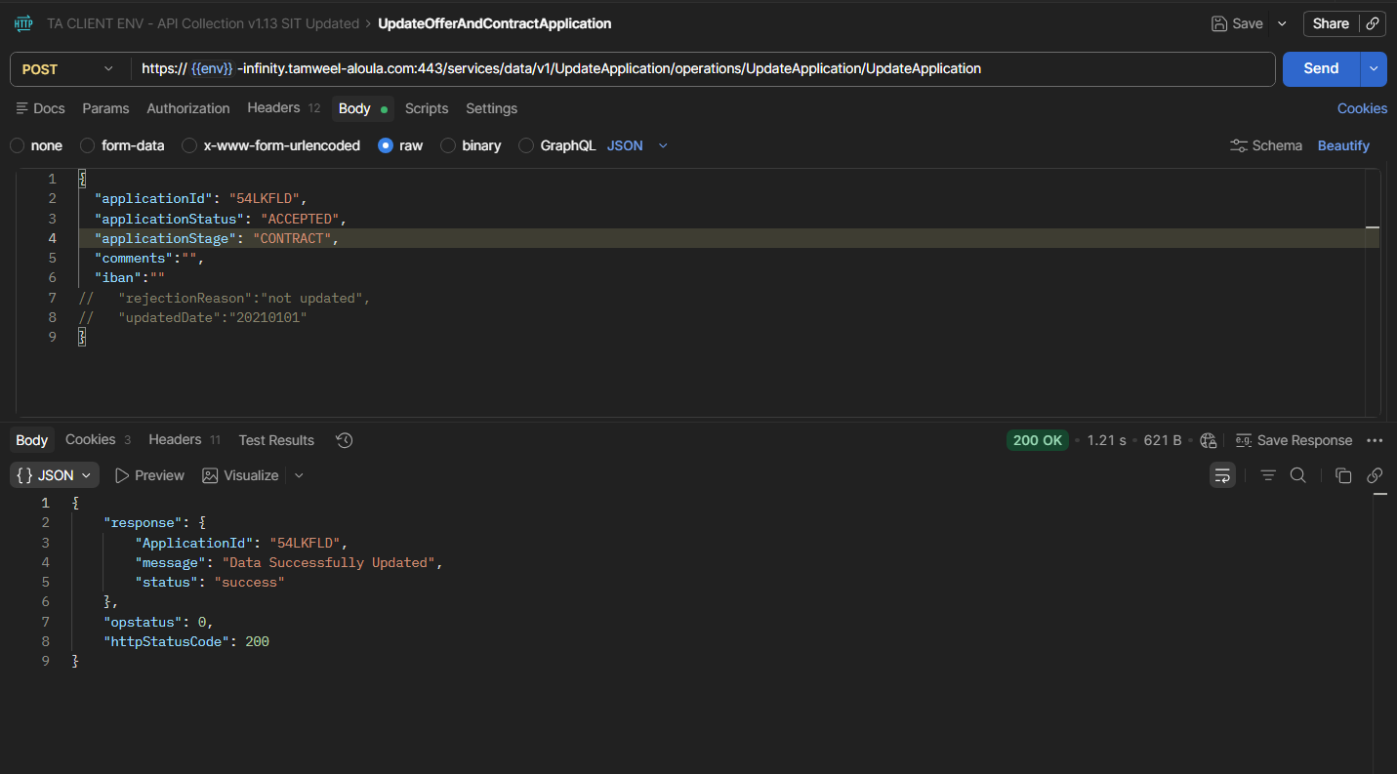
Contract status is marked as Signed.
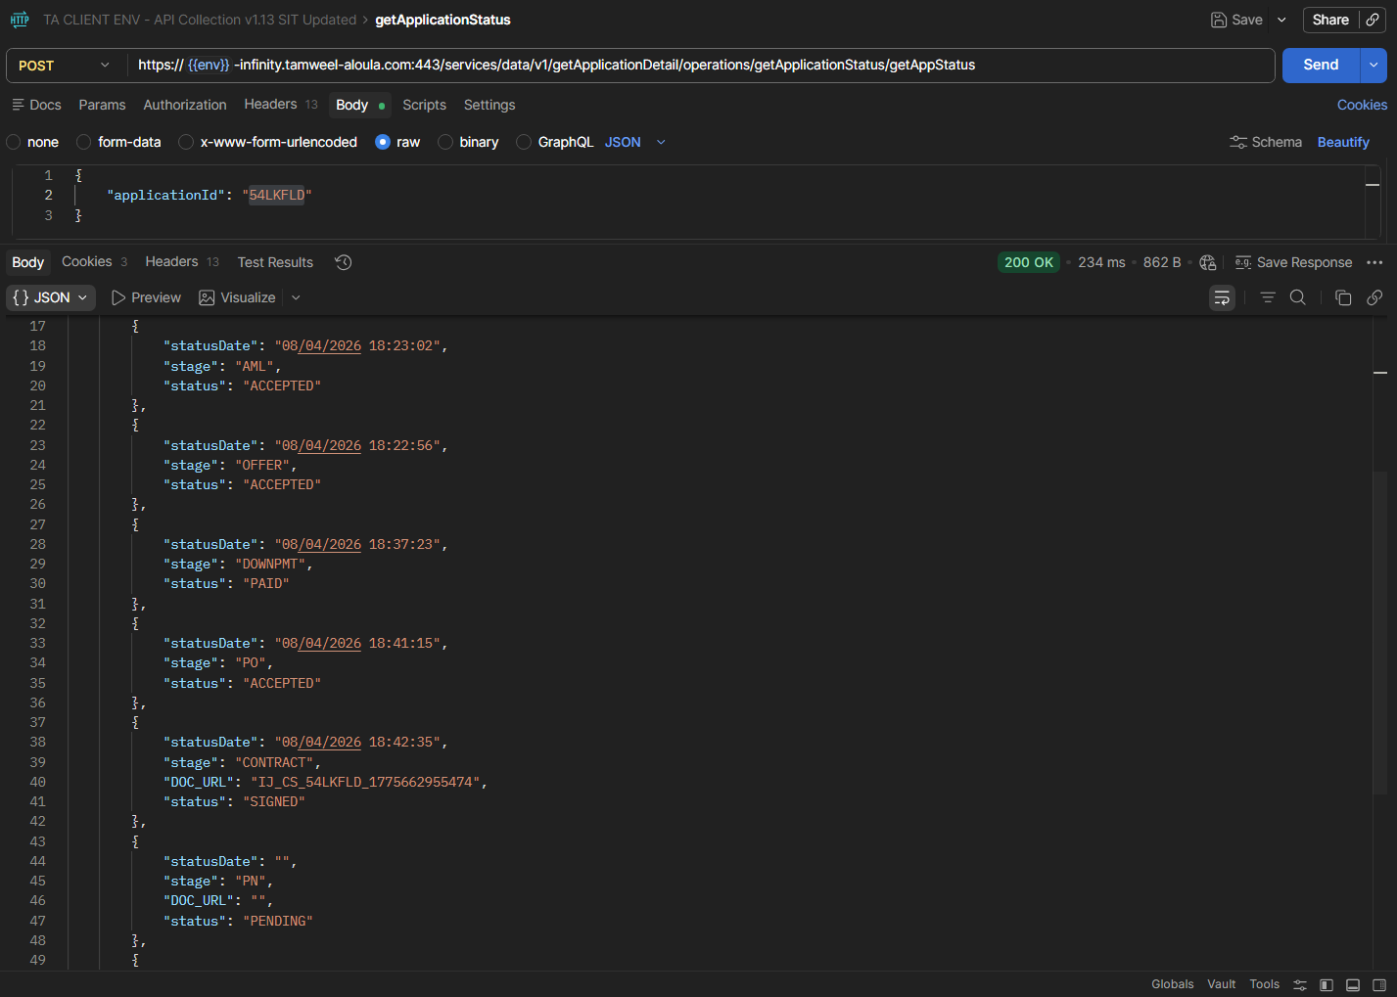

Asset Capture Amend
Click on asset capture amend.
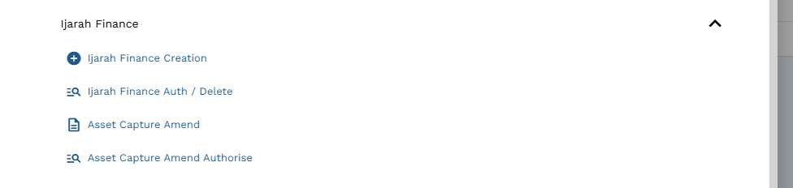

Input App ID and click edit.
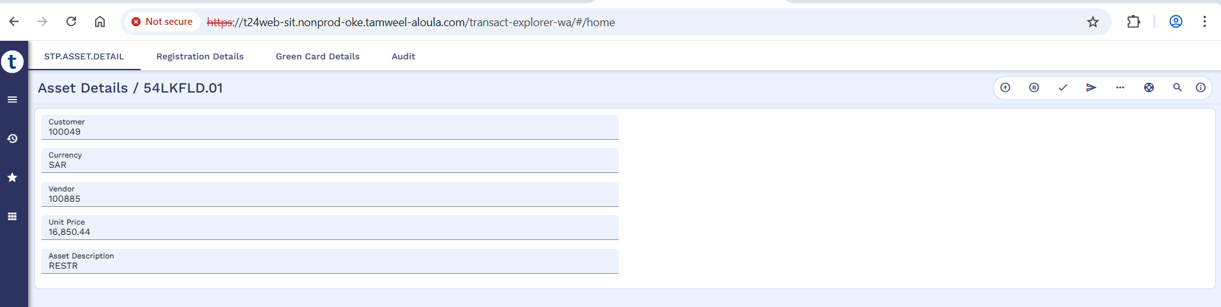

Click on Registration Details and input Registration Number, Registered At, Registration Expired on, and Istemara number. However, the Registration details will remain same as of old loan.
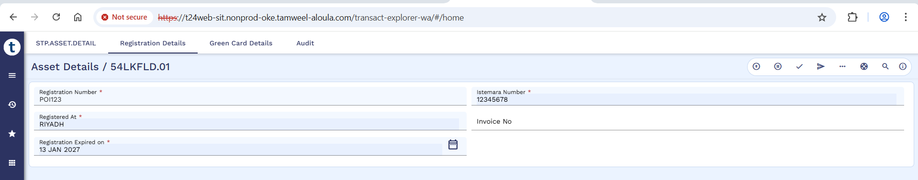

Commit the deal.
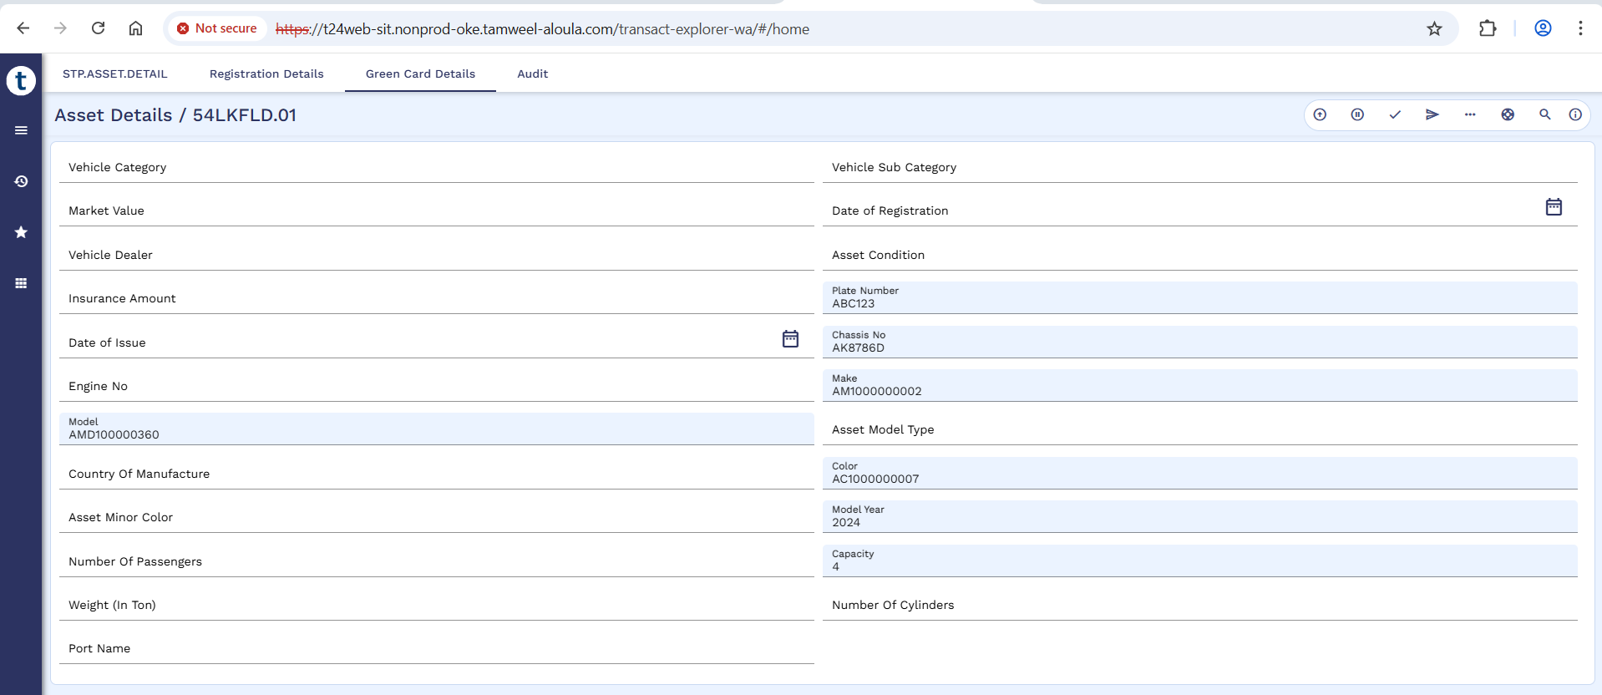
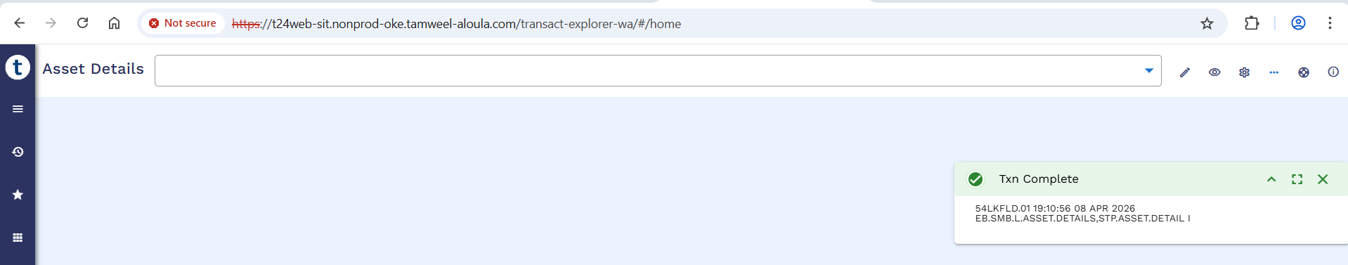

Authorization of Asset Capture Amend
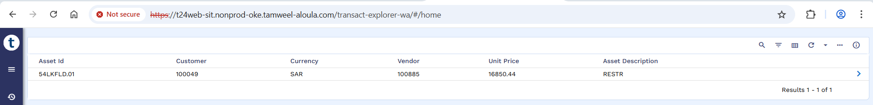
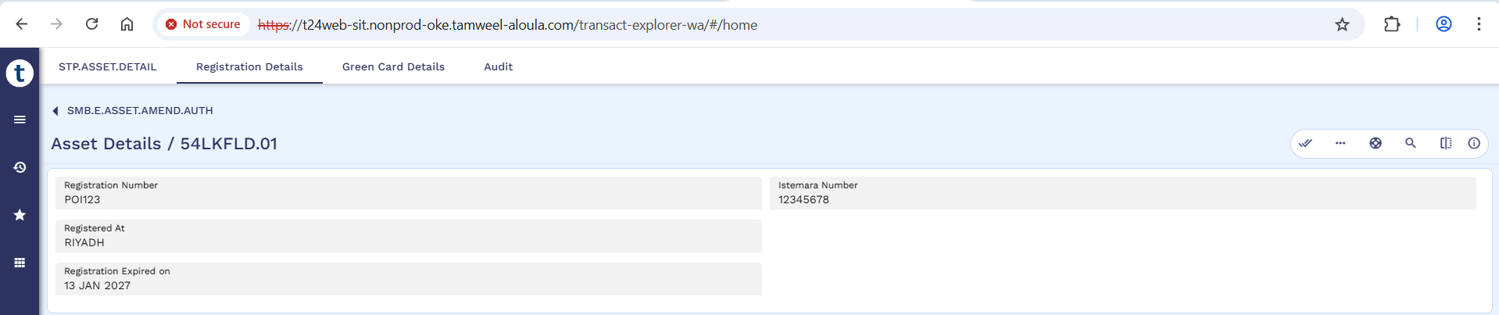
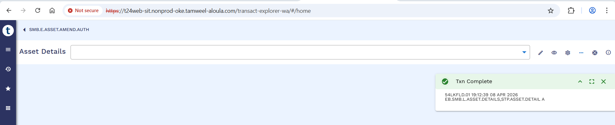

STP Status Enquiry – Complete
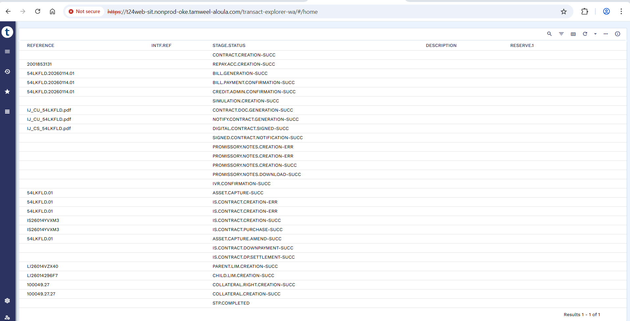

STP Accounting Entries
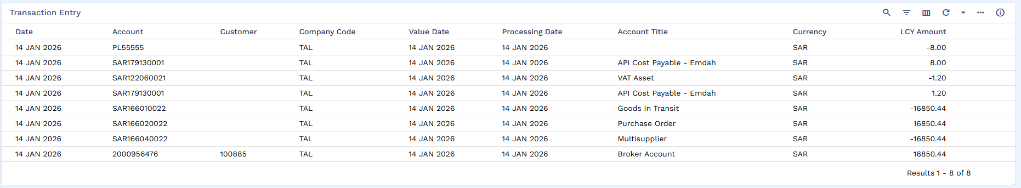

Restructured Arrangement Creation
Click on Ijarah Finance Creation.
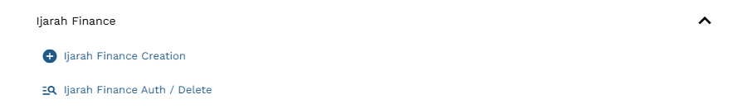
The user will manually create the Finance Arrangement with minimal inputs as some details will be auto fetch from IS Contract and SMB.DEAL.DETAILS.
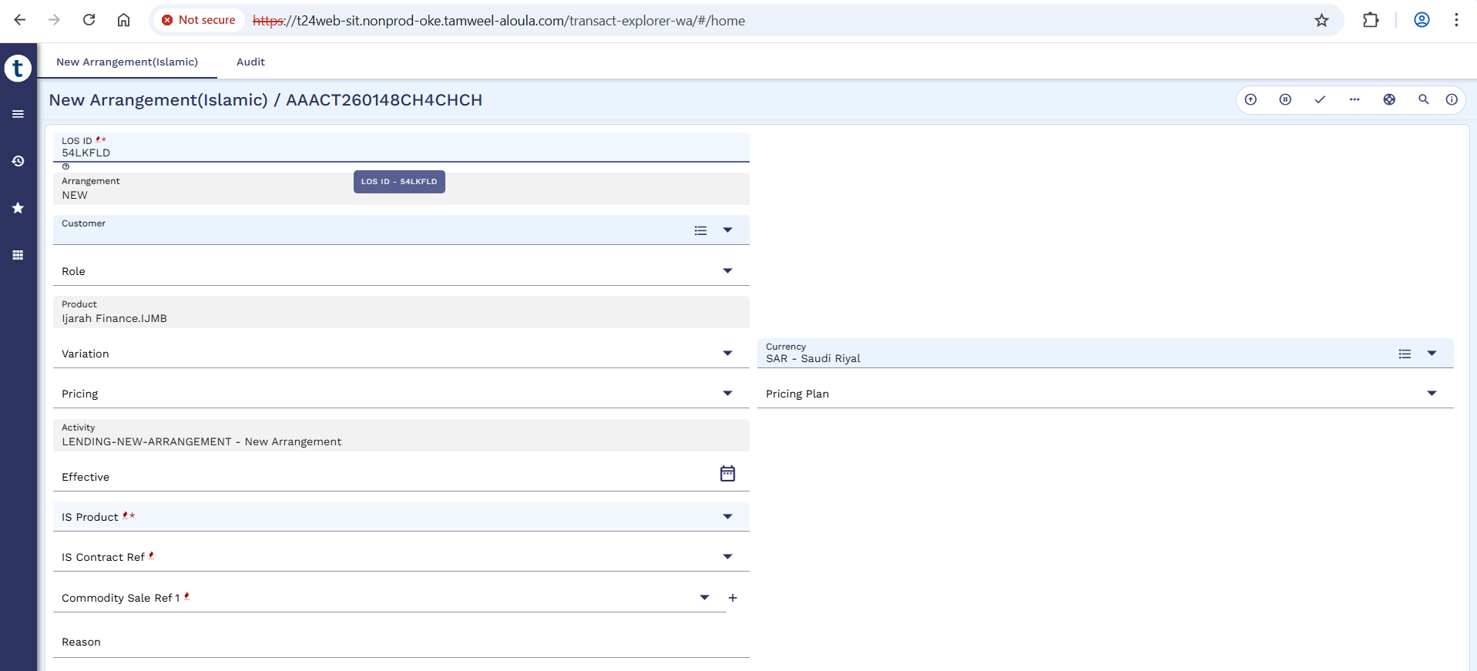
The record will auto populate.
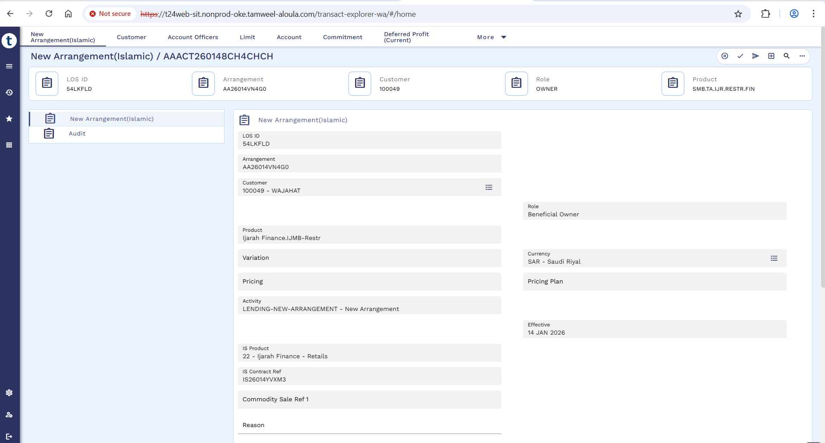

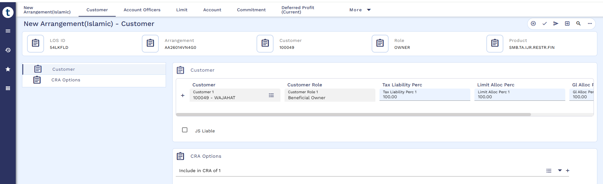
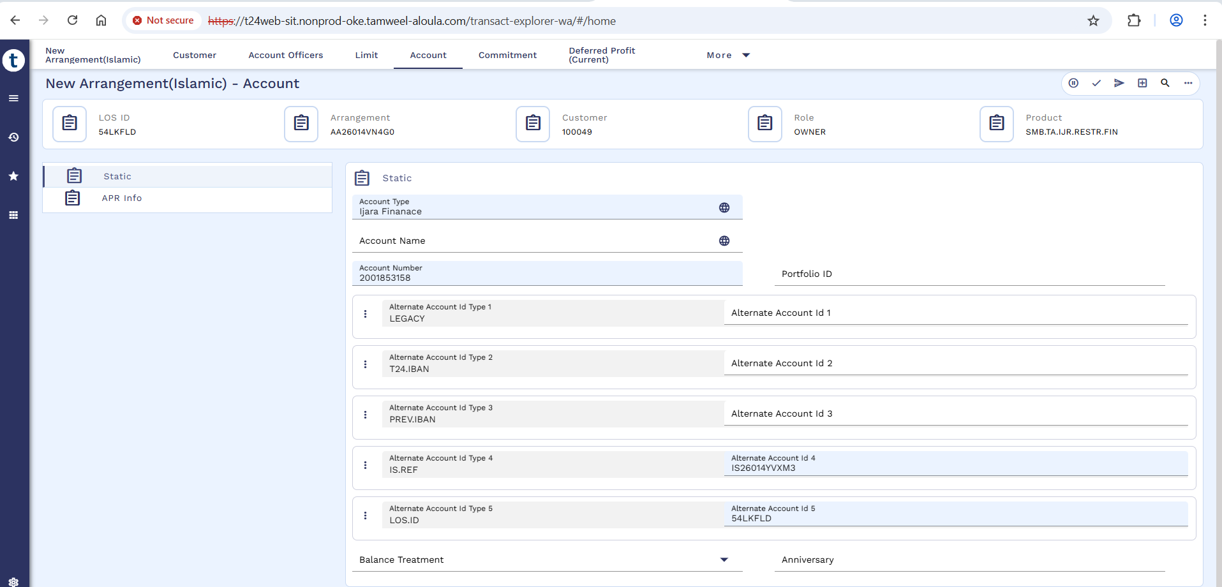
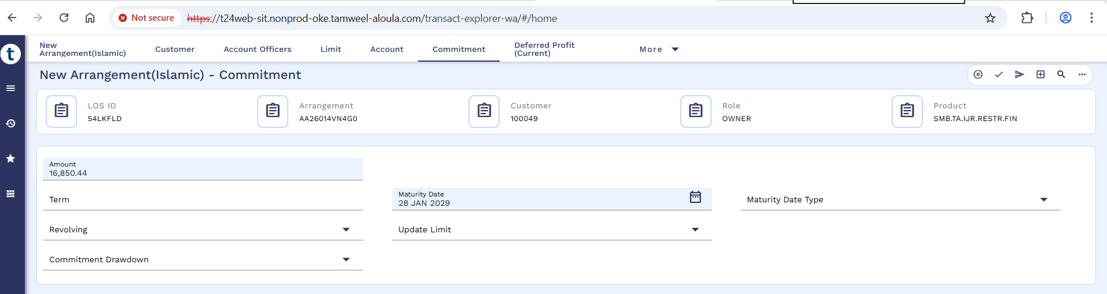
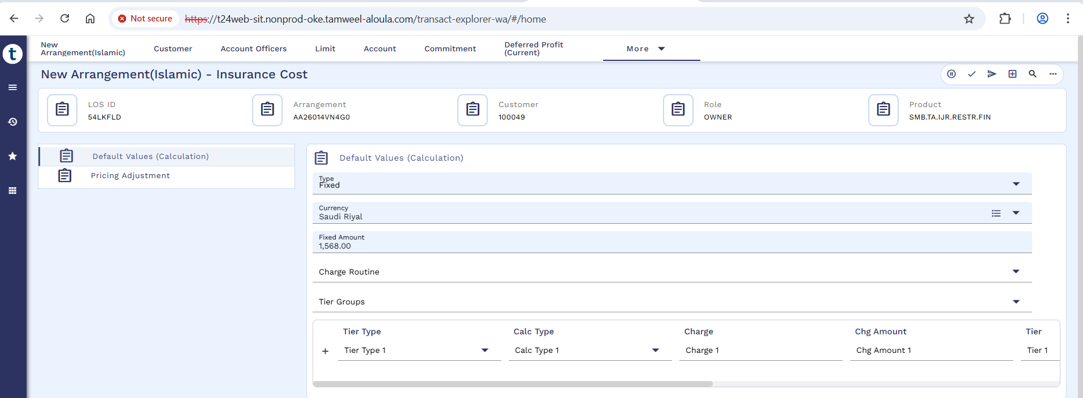
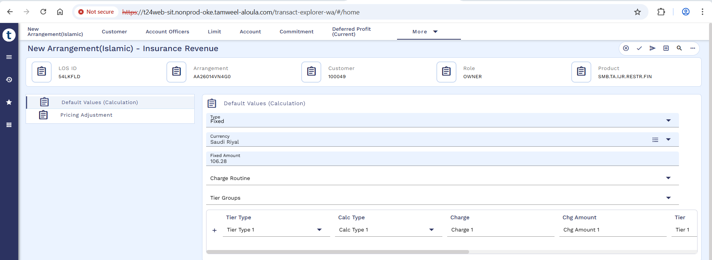
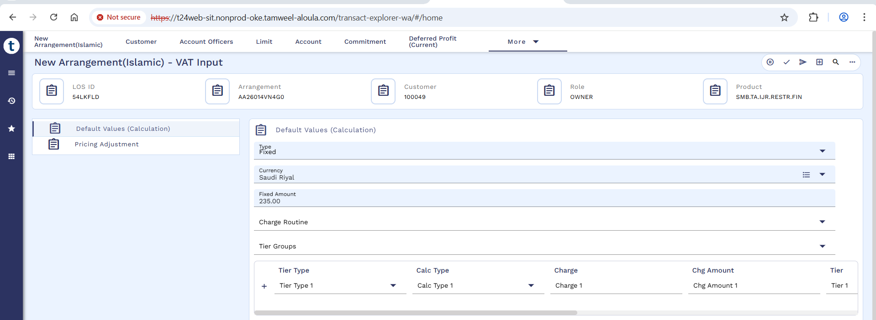
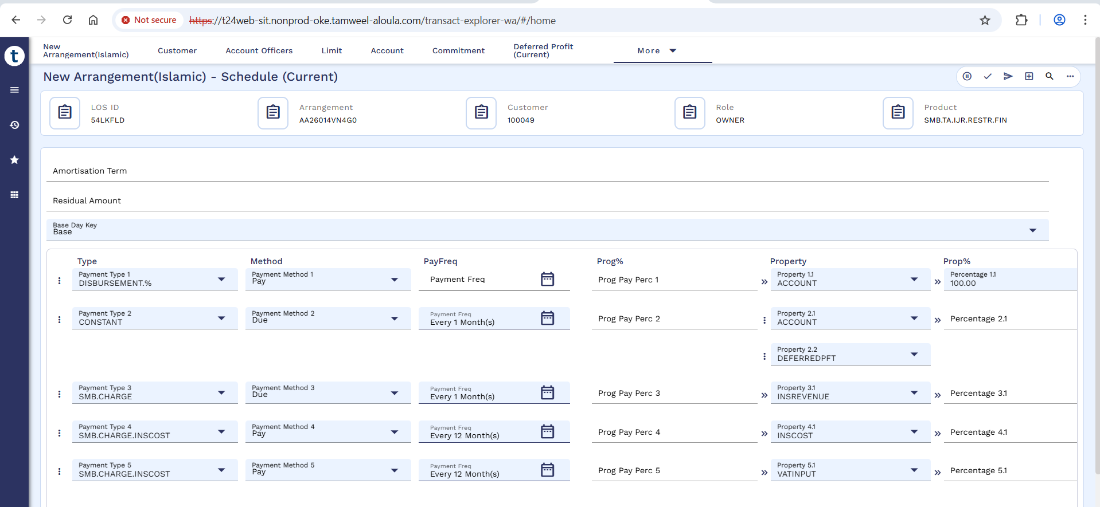

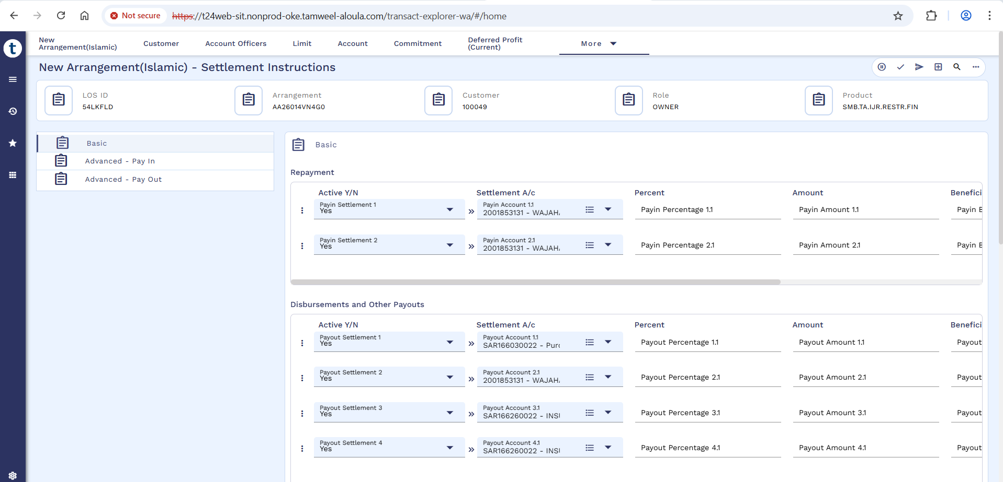
Validate and commit the deal.
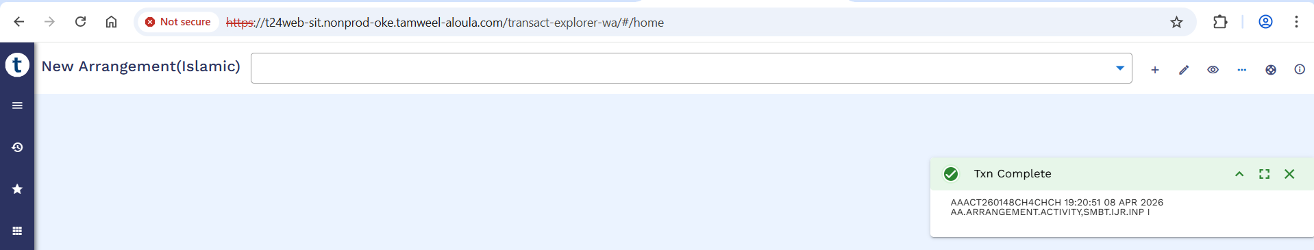

Authorization of Restructured Arrangement
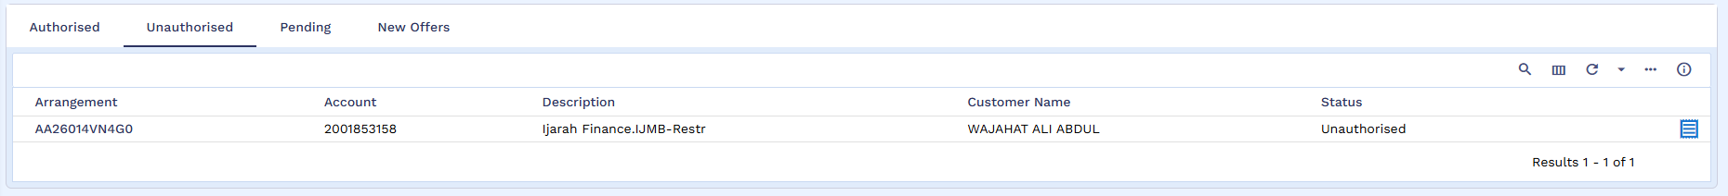
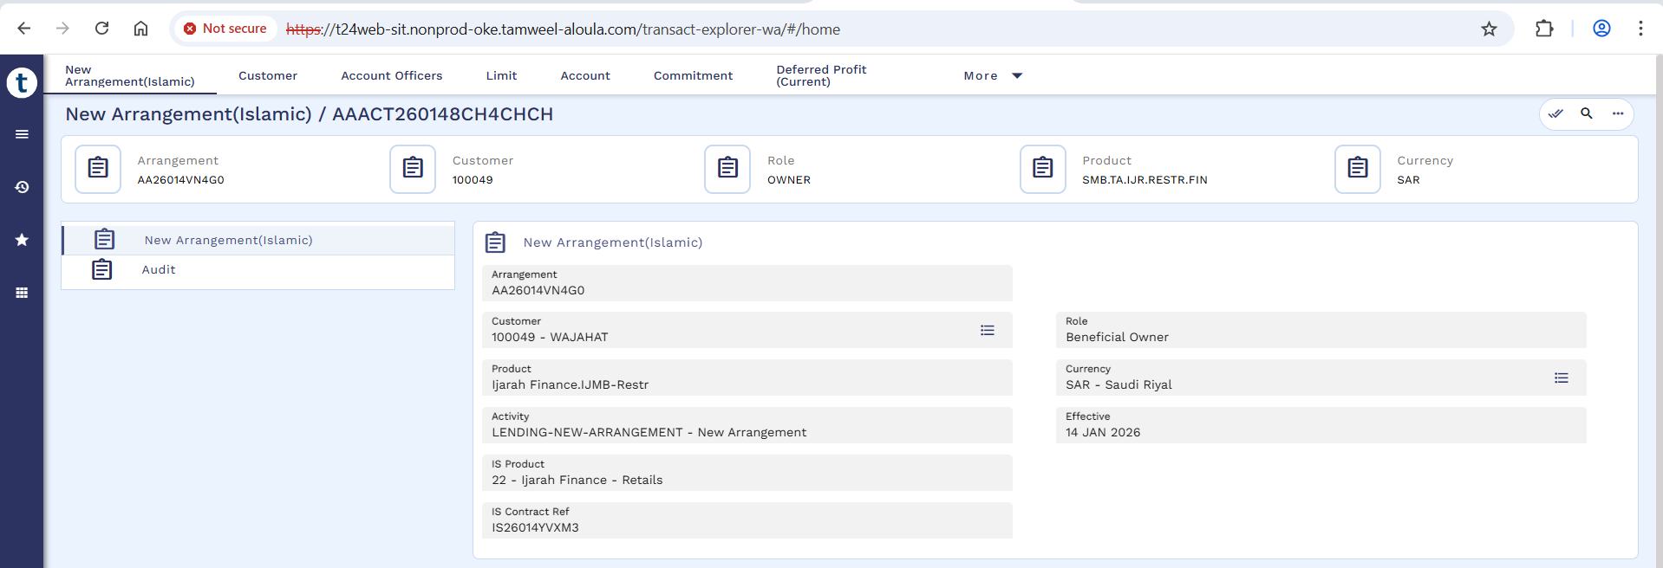

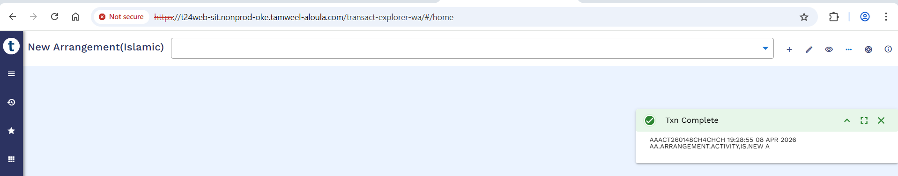

Arrangement 360 View
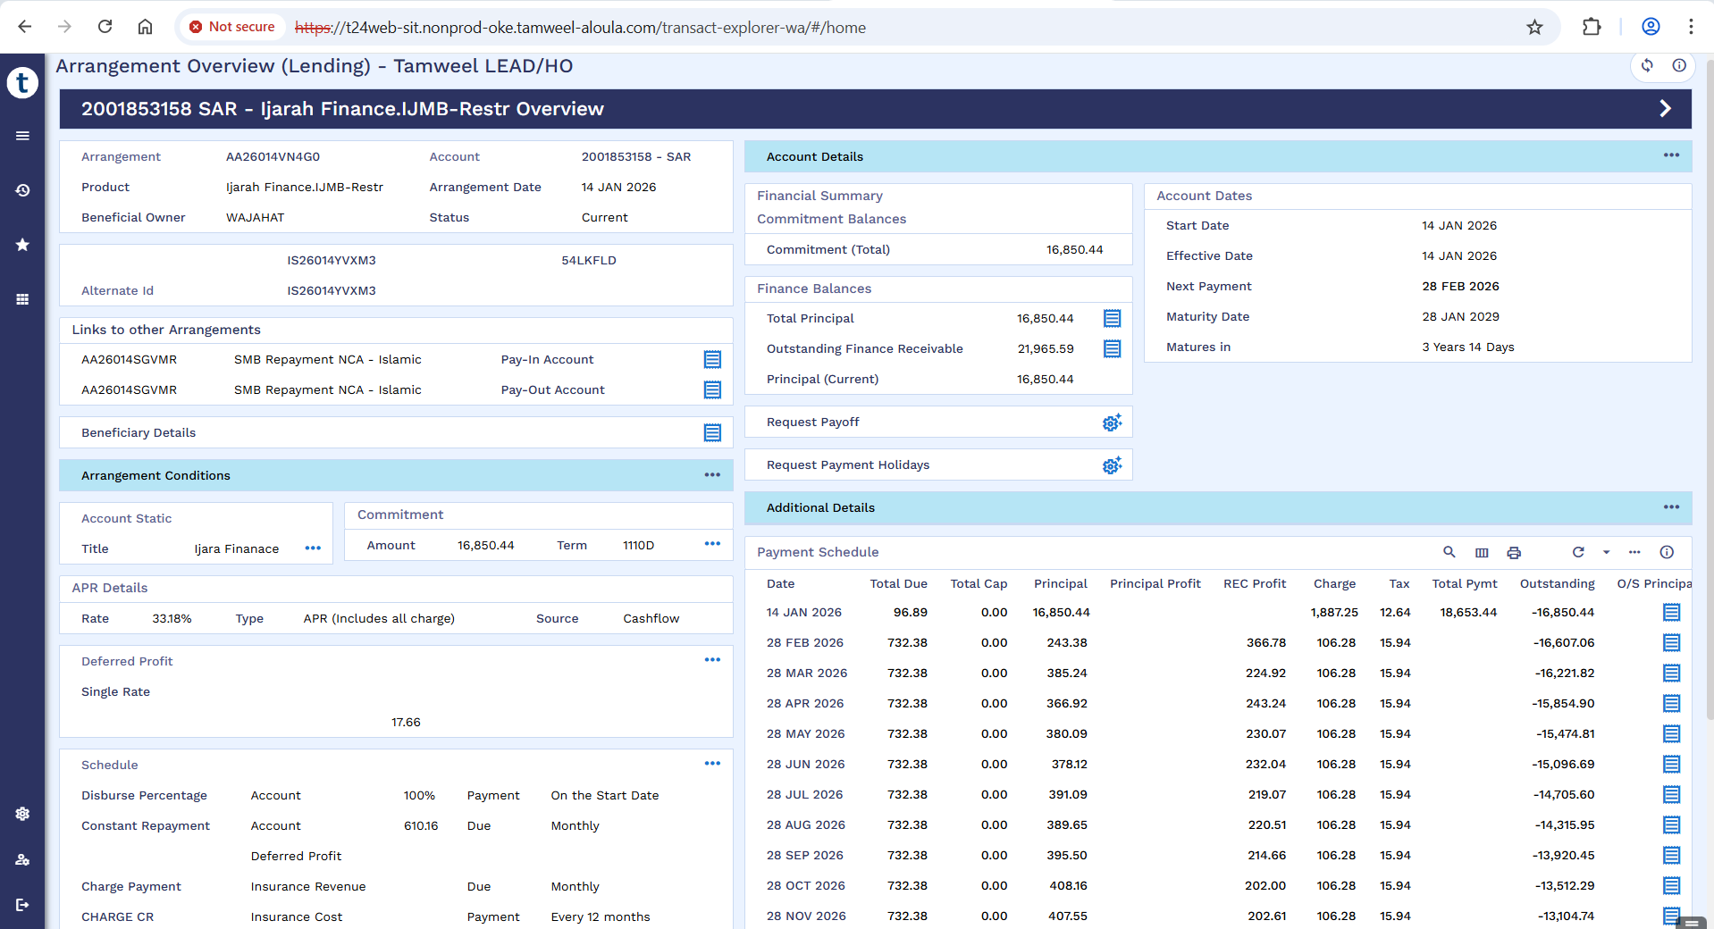

List of Transaction Entries
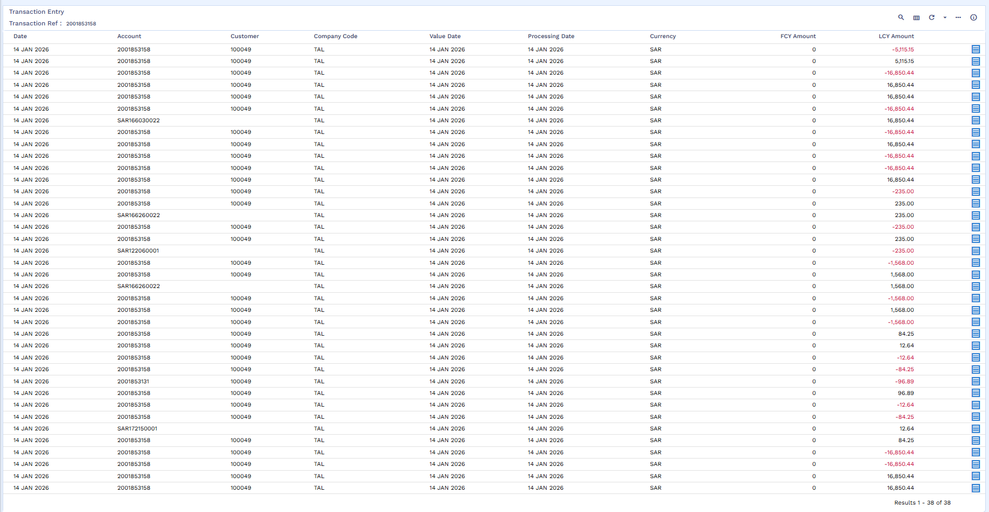

Multi-supplier Account
Below screenshot shows that the amount has been credited in Multi-supplier Account.
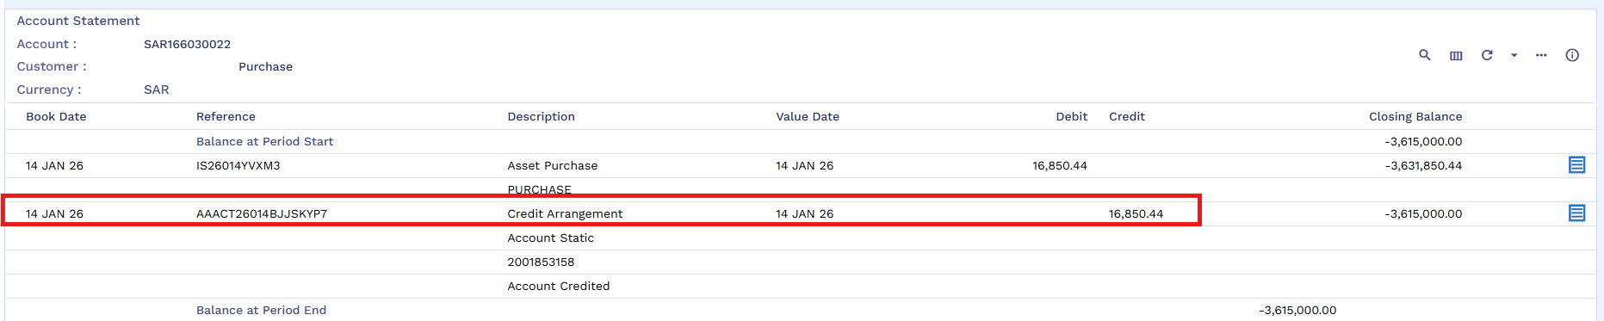

Fund Transfer
Once the new loan arrangement is booked old loan contract will be adjusted and closed from the proceed of new loan arrangement by user manually.

FT Creation
Now FT will be performed, where funds from the Multi-supplier Account will be credited to the old arrangement’s repayment account. Input the details and commit.
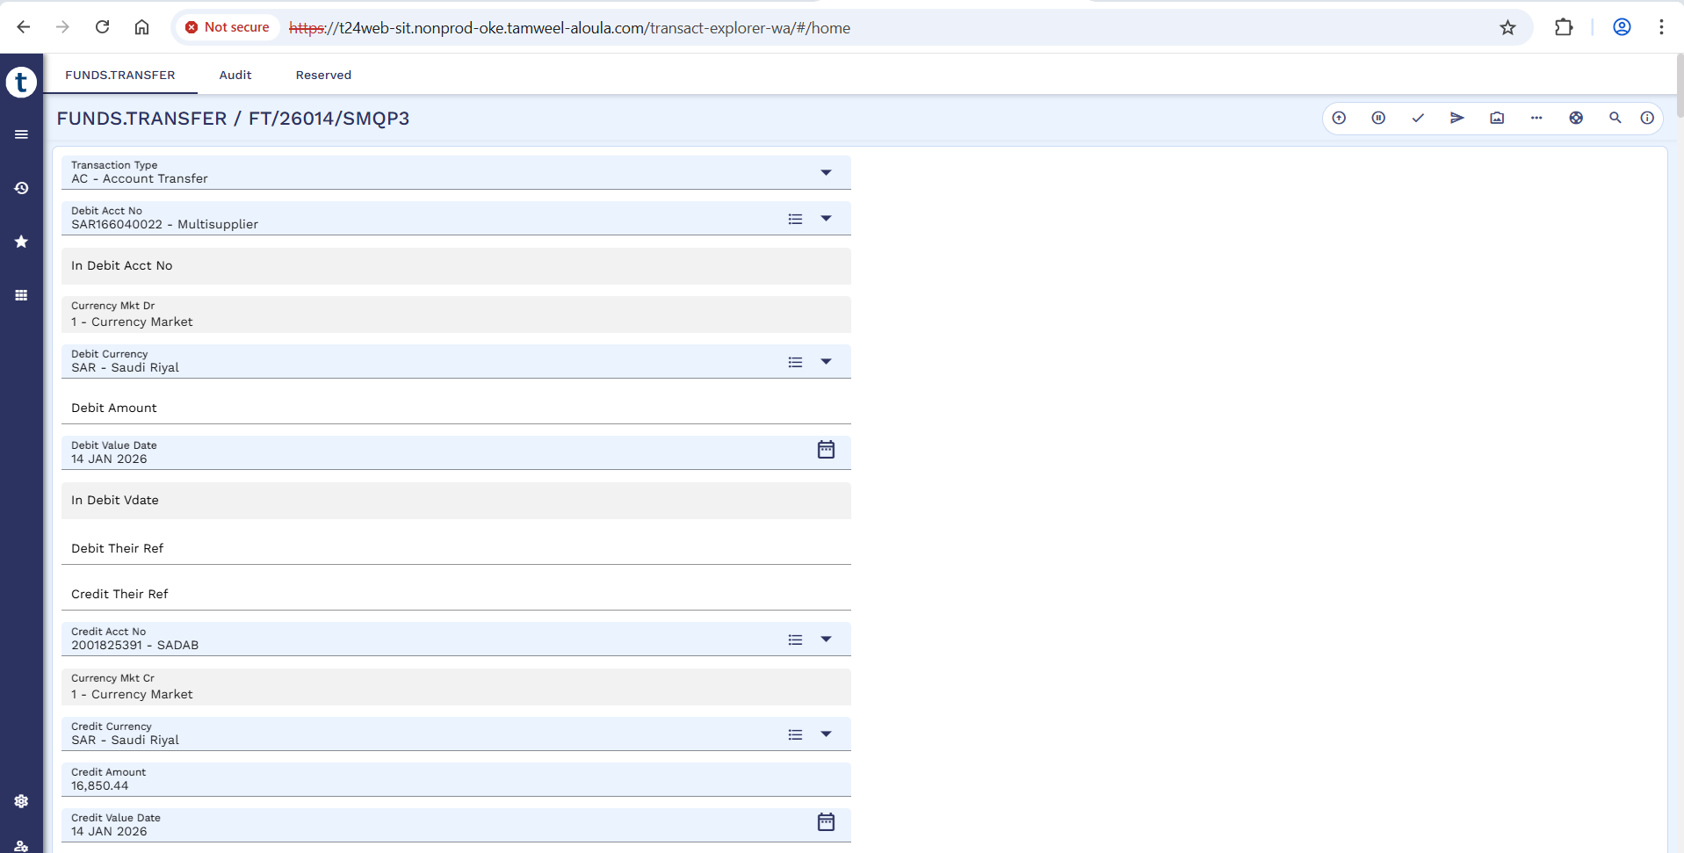
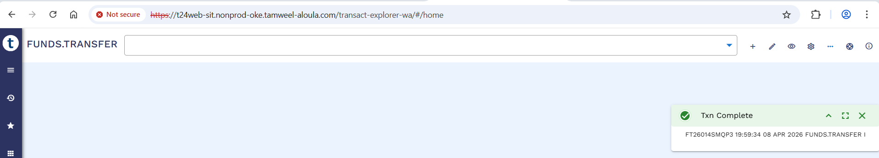

FT Authorization
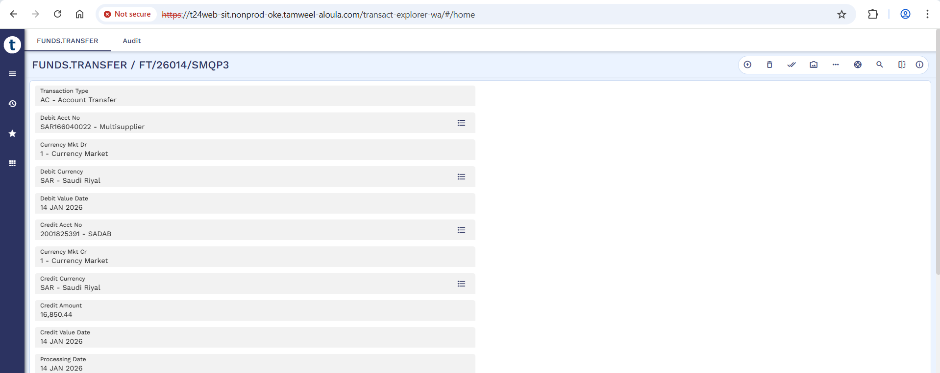
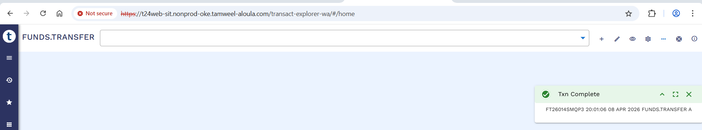

FT Credited in Previous Loan Repayment Account
Below screenshot shows the previous arrangement’s repayment account after the FT execution. The funds are credited into the repayment account.
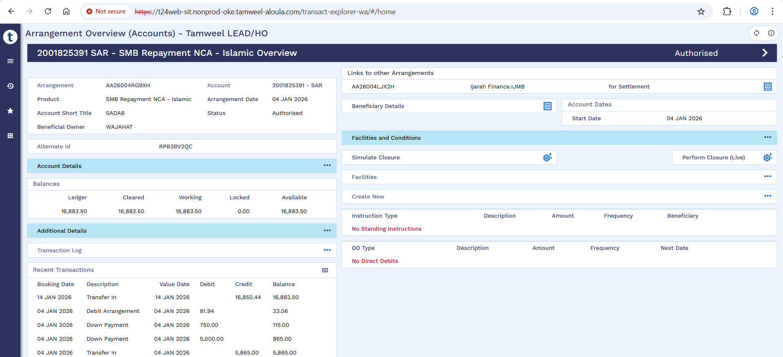

Payoff

Previous Loan Payoff
Menu -> Islamic Operations -> IS Credit Management -> Finance Transactions -> Arrangement Activities (FT) -> AA Pay-off.
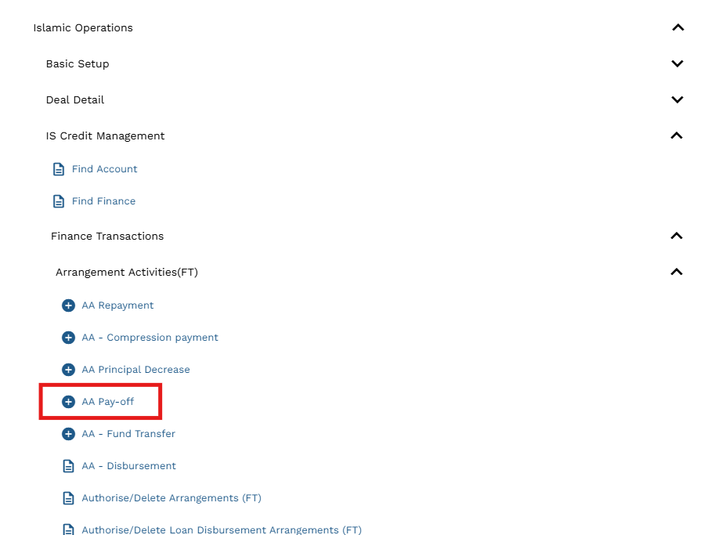

Input the credit account, debit account, credit currency and credit amount. Then validate and commit.
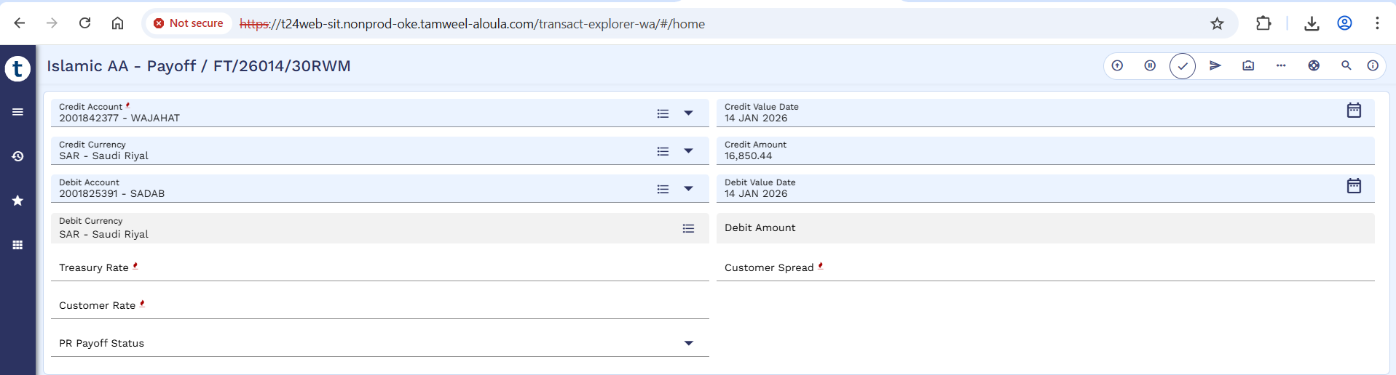
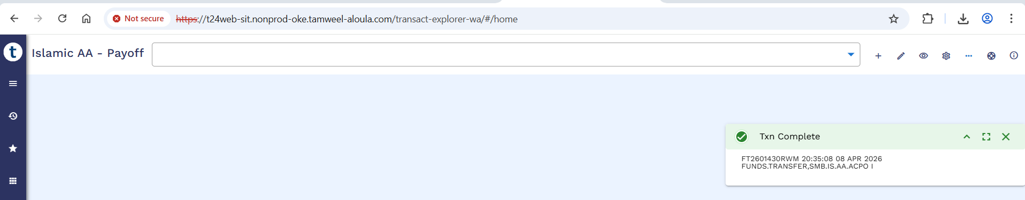

Payoff Authorization
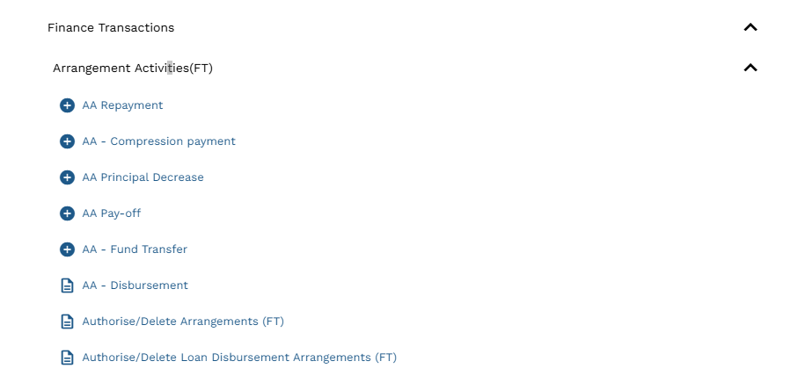

Click authorize.
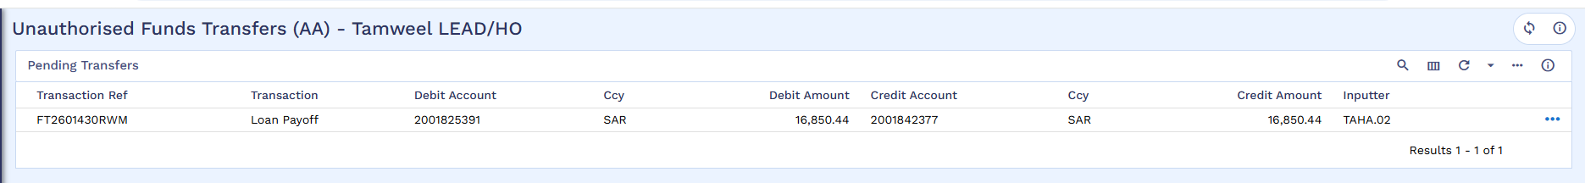

Commit the record.
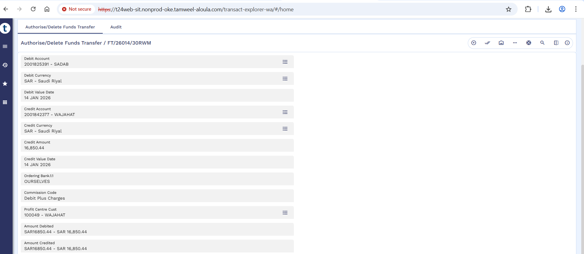

Arrangement after Payoff
Below Arrangement is the old arrangement which is settled through new restructured arrangement.
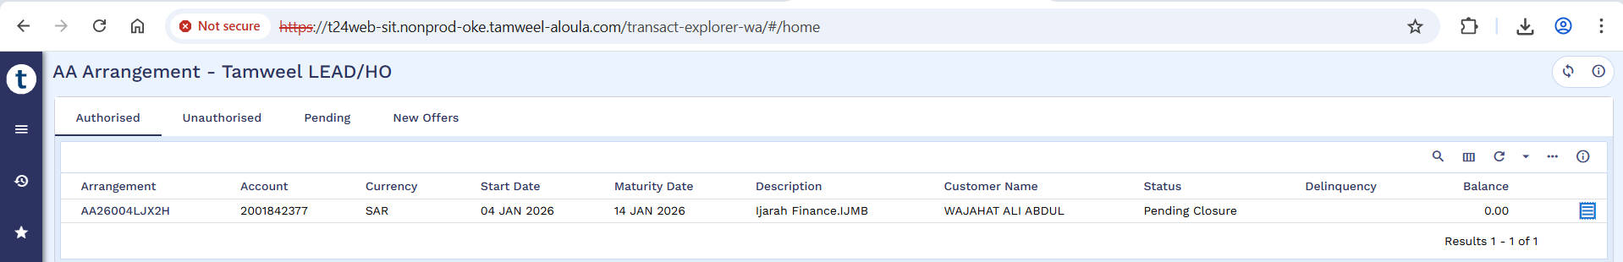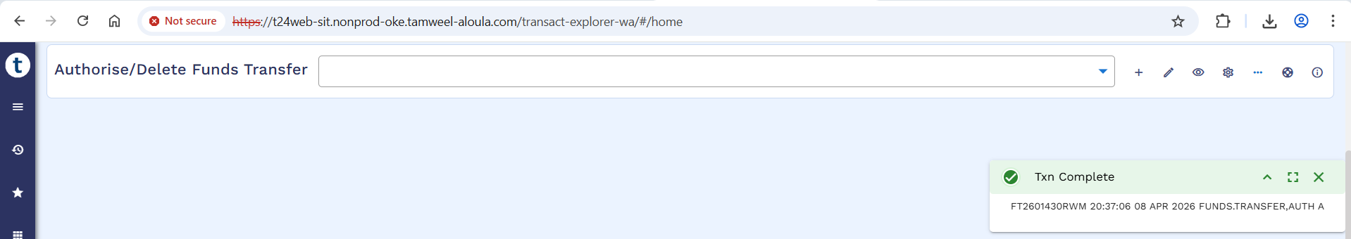
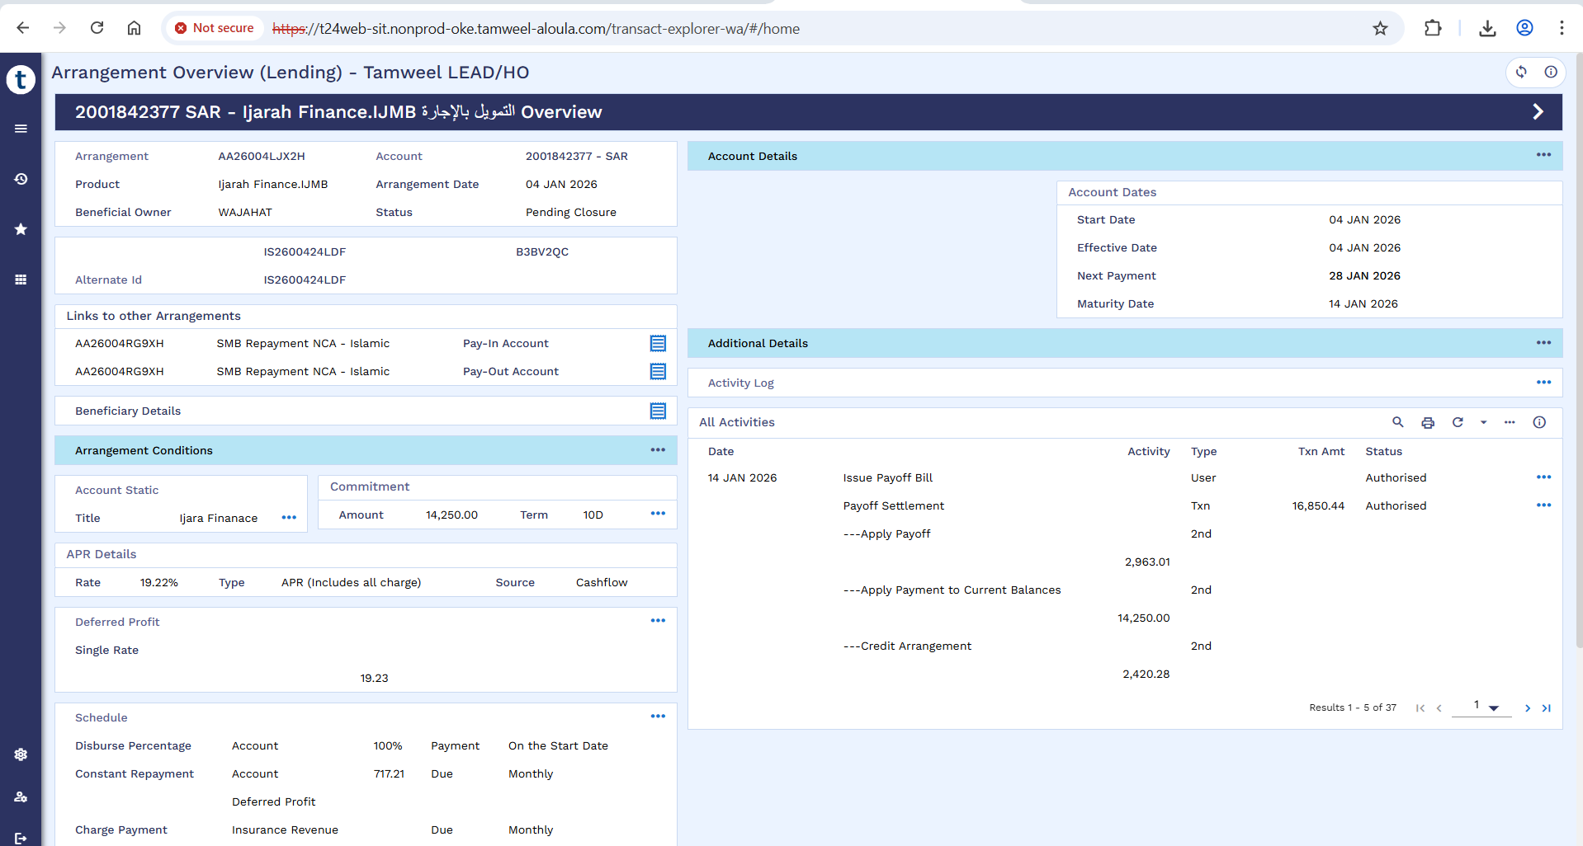

Schedule
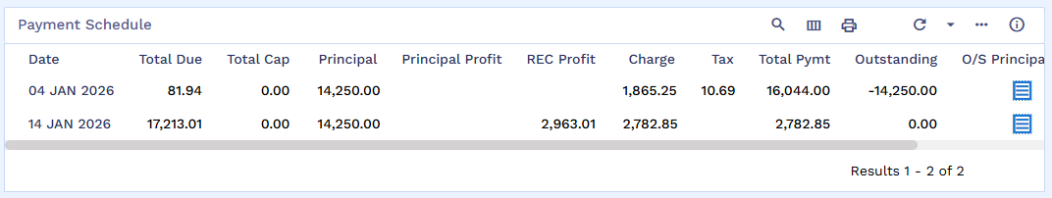

Transaction Entry After Payoff

